Vehicle-to-Vehicle Communication for Blind Spot Detection and Accident Prevention Using Severity-Gated Collision Risk Indexing
Omkar Kadam¹, Abhinav Prasad¹, Gauri Phanse¹, Afraz Khan¹, Vaishali Khairnar¹, Safia Sadruddin², Deepali Vora^{3*}
1Department of Information Technology, Terna Engineering College, Nerul, Navi Mumbai, India. 2Department of Computer Engineering, Terna Engineering College, Nerul, Navi Mumbai, India. 3Symbiosis Institute of Technology, Symbiosis International (Deemed University), Pune, 412115, India.

*Corresponding author(s). E-mail(s): deepali.vora11@sitpune.edu.in;

Abstract
Blind spot accidents during lane changes are a major cause of urban traffic collisions. Current driver-assistance systems using radar or cameras fail when other vehicles block the line of sight. This paper presents a Vehicle-to-Vehicle (V2V) Blind Spot Detection system using wireless communication to detect nearby vehicles even when hidden from sensors. The system uses only 5 data fields from the standard Basic Safety Message (BSM) — far fewer than the 13 fields required by previous systems. We introduce a Collision Risk Index (CRI) with a severity gate that prevents false alarms by requiring at least one danger signal to be genuinely high before triggering a warning. Tested over 146,051 simulated vehicle interactions on a real road network, the physics model achieves
an Area Under the Receiver Operating Characteristic curve (AUC) of 0.958 with 95% bootstrap confidence interval [0.944, 0.970] against a SUMO collision ground truth whose labels are computed independently of the CRI (n = 27), statistically significantly above the TTC kinematic, static-box, and XGBoost baselines (paired bootstrap, p < 0.001). On a complementary kinematic near-miss proxy the AUC is 0.987 with Area Under the Precision-Recall Curve (AUPRC) = 0.677 against a 0.024 random baseline. Results are stable across six independent random traffic seeds (σ = 0.0041 on AUC). An exploratory XGBoost classifier and three additional learners (LightGBM, Random Forest, Logistic Regression) are included as data-driven baselines.

Keywords: Blind Spot Detection, Collision Risk Index, DSRC/C-V2X, Severity Gate, Vehicle-to-Vehicle Communication

Introduction
Road traffic injuries cause about 1.19 million deaths worldwide every year, making it the leading cause of death for people aged 5–29 [10]. Many of these acci-dents happen when drivers change lanes without seeing vehicles in their blind spots. In India, dense and mixed traffic on urban roads makes the problem worse [11]. We state the scope of this study explicitly at the outset:
the system addresses the motorised four-wheeled sub-set of that traffic — passenger cars, SUVs, and trucks exchanging V2V messages. Vulnerable road users (pedestrians, cyclists, and two-wheelers), although a dominant component of Indian urban traffic, broadcast no Basic Safety Message and would require Personal Safety Message (PSM) handling and non-vehicular dynamics models that the 5-field pipeline studied here

does not contain; they are therefore deferred to future work (Section 10) rather than silently excluded.
The canonical failure mode is a lane-change manoeuvre in heavy traffic, illustrated in Fig. 1. The ego vehicle (a sedan in the middle lane) signals a merge into the adjacent right-hand lane. A heavy truck travelling alongside in the ego’s own lane physically occludes the ego’s onboard radar and camera, hiding a faster sedan that is approaching from behind in the des-tination lane. The hidden vehicle sits squarely inside the ego’s right-side blind spot. The driver, receiving no sensor alert, initiates the lane change, and the rear-end speed difference leaves the approaching vehicle no time to brake. Side-swipe collisions of this kind account for a non-trivial share of urban lane-change crashes [14], and they cannot be eliminated by improving sensor resolution alone — the line-of-sight is geometrically blocked.
Vehicle-to-Vehicle (V2V) communication addresses this gap by letting vehicles exchange short safety messages over radio links that propagate around obstructions. V2V is not intended as a substitute for radar or camera sensing; it is a third sensing modality, used in combination with the on-board sensors to cover precisely those situations where line-of-sight is geometrically impossible. Each vehicle broadcasts its location, speed, and acceleration as a Basic Safety Message (BSM) [1, 2] at 10 Hz, with an effective range of up to roughly 300 m on either Dedicated Short-Range Communication (DSRC, IEEE 802.11p) [3] or Cellular V2X (C-V2X, 3GPP) [4].
Previous V2V blind-spot systems consume up to 13 BSM fields, including heading angle, turn signal indi-cators, and yaw rate [12]. Requiring those extra fields excludes vehicles whose on-board units broadcast only the mandatory Part I message, and it creates a hard dependency on CAN-bus access for signals such as the turn indicator. The system presented here uses only five fields — GPS position (x, y), speed (v), accelera-tion (a), and braking magnitude (d) — and derives the remaining quantities (heading, yaw rate, lane-change intent) from position history.
The main contributions are:
- Severity-gated Collision Risk Index. A risk for-mula requiring at least one genuinely high danger signal before triggering a warning, preventing false alarms from small values adding up.
- Minimal 5-field BSM. Eliminates the need for 13 fields, making the system compatible with all vehicle types.
- Exploratory ML baseline comparison. An XGBoost classifier reveals that physics models out-perform data-driven approaches when dangerous events are rare.
- Realistic testing. Tested on a real road network with traffic signal violations, narrow hilly roads, and simulated communication failures.

Related Work
Research on blind-spot detection has converged from three originally separate communities — sensor-based driver-assistance systems, V2V communication pro-tocols, and learning-based risk assessment — and a fourth, C-V2X cooperative perception, has emerged more recently. This section covers each in turn.

Sensor-Based and V2V Blind Spot Detection
Current commercial systems use radar sensors on rear bumpers, which work well on open roads but fail in dense traffic where large vehicles block signals. V2V communication overcomes this as radio signals pass through vehicles. V2V systems use SAE J2735 [1] for message formatting and IEEE 802.11p [3] for trans-mission. The SAE J2945/1 standard [2] requires 10 Hz BSM broadcasts. Our system uses only 5 BSM Part I fields, compatible with basic on-board units [13].

Risk Assessment and Machine Learning
Time-to-Collision (TTC), introduced by Hayward [19] and since extended into a family of surrogate safety measures [20], is widely used in Euro NCAP testing [5] but becomes unreliable with lateral vehicle movement. Early V2V systems used shared GPS coordinates [17]; Kim et al. developed threat assessment using V2V data [16]; Mousa et al. created a 13-field V2V blind spot system [12]. A common problem is that multiple small risk values trigger false warnings — our sever-ity gate prevents this. Machine learning models like XGBoost work well for structured data, but raise inter-pretability concerns for safety decisions. The Synthetic Minority Over-sampling Technique (SMOTE) [15] helps handle rare dangerous events by interpolat-ing new minority-class samples in feature space. In our system, an XGBoost classifier is included as an exploratory comparison only.

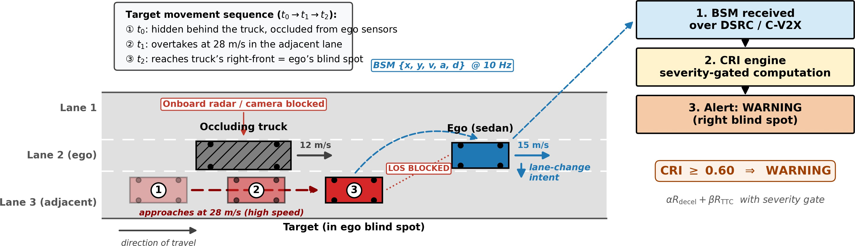

Fig. 1 Lane-change blind-spot scenario with driving directions and movement sequence. All traffic moves left to right at the speeds annotated on each vehicle (truck 12 m/s, ego 15 m/s, target 28 m/s). The numbered ghost positions trace the target’s manoeuvre: at t₀ (⃝1 ) it is hidden behind the truck and occluded from the ego’s sensors; at t₁ (⃝2 ) it overtakes at high speed in the adjacent lane; at t₂ (⃝3 ) it reaches the truck’s right-front — exactly the ego’s right blind spot — as the ego signals its lane change. The occluding truck blocks the ego’s onboard radar/camera line of sight, but the 5-field BSM from the target reaches the ego over the V2V radio link. The receiver feeds the BSM into the Collision Risk Index (CRI) engine, which applies a severity gate and raises a WARNING alert before the lane change completes.

C-V2X Cooperative Perception
A more recent line of work moves beyond single-vehicle BSM exchange to full cooperative perception, in which connected vehicles share raw or feature-level sensor data over the C-V2X link to extend each other’s perceptual range. OPV2V [26] introduced an open simulation benchmark with multi-vehicle LiDAR fusion. V2X-ViT [27] extended this to a vision-transformer-based fusion backbone that is robust to localisation noise. V2V4Real [28] contributed the first real-world multi-vehicle perception dataset, col-lected on public roads. V2X-Sim [29] formalises the multi-agent collaborative-perception setting as a bench-mark with both BEV-detection and segmentation tasks. Two recent surveys give a comprehensive overview of the design space [30, 31], and Garlichs et al. [32] discuss the standardisation considerations for produc-tion C-V2X. The work presented here is intentionally complementary to that body of literature: it operates entirely within the minimum BSM Part I envelope, with no shared sensor data, no bandwidth-heavy LiDAR sweeps, and no neural-network-scale inference bud-get. That makes it deployable on the simplest legal on-board unit, but it also means it does not solve the broader cooperative-perception problem — cooperative perception adds non-line-of-sight detection of non-V2V-equipped traffic, which 5-field BSM exchange cannot do.

System Architecture
The system is organized as a four-layer pipeline (Fig. 2): Layer 1 (Simulation): Eclipse SUMO [9] gen-erates vehicle movements at 10 Hz with injected danger scenarios. Layer 2 (Communication): Vehicle data is packaged into 5-field BSMs with GPS noise (1.5 m) and packet drops (Gilbert–Elliott model [7, 22]). Lost messages trigger dead-reckoning prediction. Layer 3 (Intelligence): Two parallel paths process received data — a physics model (primary, CRI-based) and an XGBoost classifier (exploratory baseline). Layer 4 (Analytics): A Streamlit dashboard displays real-time V2V connections and risk scores.
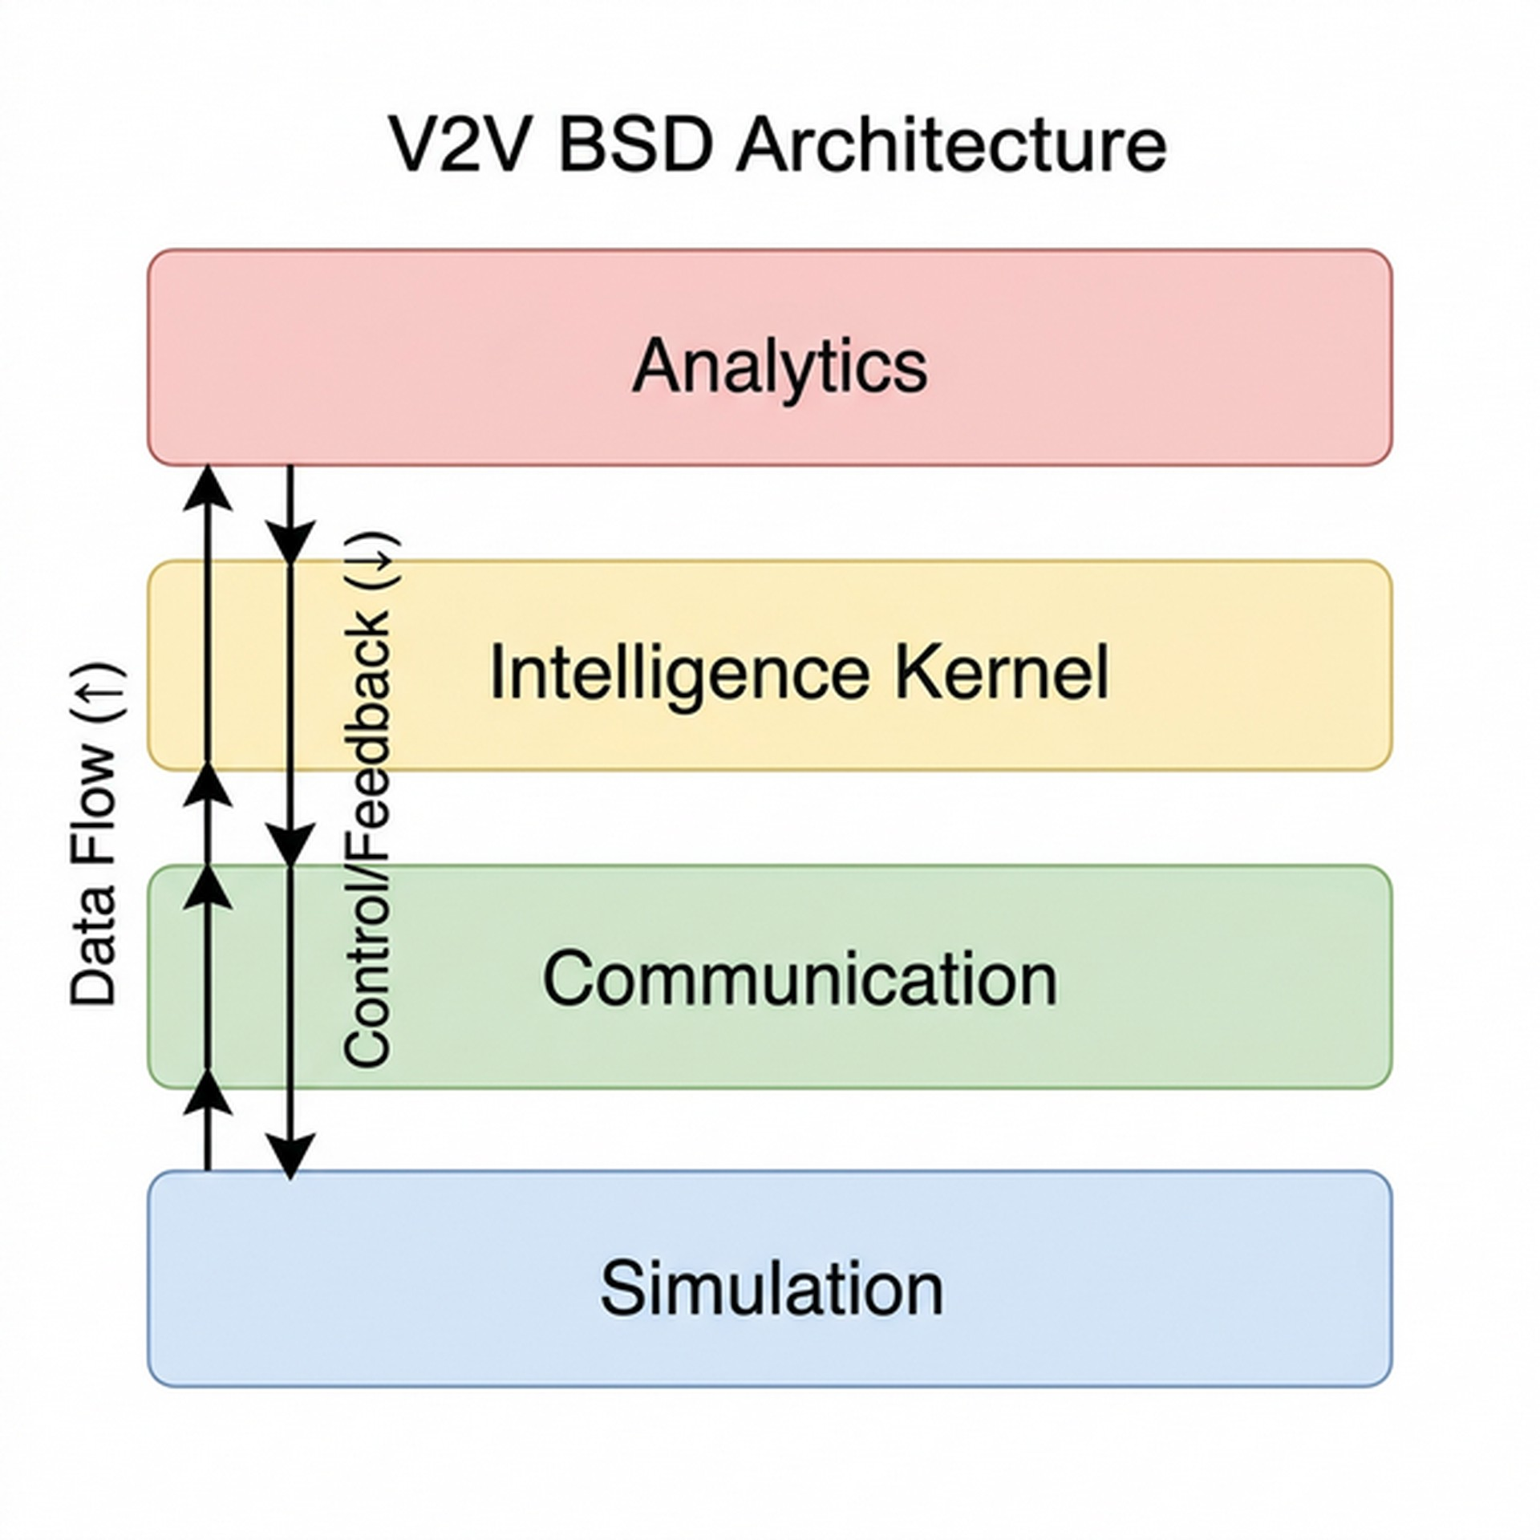
Fig. 2 Four-layer V2V BSD system architecture.

Mathematical Model
The system takes 5 data fields from each nearby vehicle and produces a risk score between 0 (safe) and 1 (criti-cal). The model is presented bottom-up in seven steps:
(i) heading recovery from raw BSM positions, (ii) trans-
Table 1 Notation used in the mathematical model

Symbol Meaning

x, y GPS position in local UTM frame (m)
v scalar speed (m/s)
a, d acceleration / braking magnitude (m/s²)

formation into the ego frame and the speed-dependent
θ , θ˙
derived heading (rad) and yaw rate (rad/s)

blind-spot zone, (iii) the probabilistic zone-occupancy term P_{gps}, (iv) dead reckoning under packet loss and the penalty Γ_{plr}, (v)–(vii) the three risk components R_{decel}, R_{ttc}, and R_{intent}. Equation (16) then combines all terms into the final CRI. Table 1 collects the principal notation used throughout this section; every symbol is also defined in prose at its first use, and the numeric constants are gathered in the parameter reference table
x_{rel}, y_{rel} target position in ego frame (m)
clip[0,1](·) bound to the unit interval, min(1, max(0,·))
s normalised ego-speed fraction, s ∈ [0, 1]
L_{bs} speed-dependent blind-spot zone length (m) L_{e},W_{e}, W_{t} ego length and width; target width (m) W_{lane} lane width (m)
P_{gps} probability target occupies the zone
Φ, σ standard normal CDF; GPS position s.d. (m)
v_{min}, v_{max} zone-extension speed range (m/s)

of Section 6. Where a formula would otherwise need a
xˆ, yˆ
dead-reckoned position prediction (m)

deeply nested single-line expression, it is instead pre-sented as a short named intermediate quantity followed by the quantity of interest — the presentation used for the zone length in Eq. (4) and for the TTC risk in Eq. (13) — and each such equation is followed by a paragraph that reads the formula line by line and gives worked numeric values.

BSM Input and Heading Estimation
The 5-field BSM is BSM = {x, y, v, a, d}, where x and y are GPS coordinates (converted to metres in a local UTM frame), v is the scalar speed, a is the positive
part of the signed acceleration, and d is the positive part of the deceleration. Heading is not transmitted; it is recovered from two consecutive positions using the four-quadrant inverse tangent:

θ (t) = atan2(︁y(t) − y(t − 1), x(t) − x(t − 1))︁ (1)

This means the heading vector is the direction from the previous reported position to the current one, which equals the true heading when the vehicle is moving and the GPS noise is small relative to the displacement between samples. At speeds below 0.5 m/s the displace-ment between consecutive samples can be smaller than the GPS noise itself, so the heading of Eq. (1) is held
at θ (t − 1) instead of being recomputed — otherwise GPS jitter would rotate the heading by tens of degrees
while the vehicle is essentially stationary. The yaw rate is then θ˙(t) = [θ (t) − θ (t − 1)]/∆t with ∆t = 0.1 s.
Γ_{plr} packet-loss risk multiplier
µ, ρ tyre-road friction coefficient; air density (kg/m³)
a_{max} maximum braking capability (m/s²)
D_{stop} total stopping distance (m)
d_{gap} current inter-vehicle gap (m)
R_{decel} stopping-distance risk component v_{rel}, a_{rel} relative closing speed / acceleration τ candidate time-to-collision root (s)
TTC time-to-collision (s) [19]
κ, κ₀ TTC urgency ratio and its cut-off R_{ttc,lon}, R_{ttc,lat} longitudinal / lateral TTC risk R_{ttc} combined TTC risk component
R_{intent} lane-change-intent risk component
α, β , γ CRI component weights
CRI Collision Risk Index (final score)

Coordinate Transformation and Blind Spot Zone
The target’s position is transformed into the ego vehicle’s reference frame:

x_{rel} = sin(θ_{e}) · ∆x − cos(θ_{e}) · ∆y (2)
y_{rel} = cos(θ_{e}) · ∆x + sin(θ_{e}) · ∆y (3)

where ∆x = x_{t} − x_{e}, ∆y = y_{t} − y_{e}.

Speed-dependent zone length. The blind-spot zone lengthens with ego speed, because a faster ego covers more ground before a merging target can be reacted to. The zone length is defined in two steps: a dimen-
sionless speed fraction s(v_{e}) that saturates at both ends, and a linear interpolation of the zone length between

its base and its maximum,

s(v_{e}) = clip[0,1]

v_{e} − v_{min} ,
vmax − vmin
(︃ )︃

(4)

Blind Spot Zone Probability
Since GPS has 1.5 m uncertainty, the system calculates the probability of a target being in the blind spot using Gaussian integration:

L_{bs}(v_{e}) = L_{base} + λ_{scale} · s(v_{e}),

P_{lat} = Φ
(︃ xmax − xc )︃
— Φ(︃ xmin − xc )︃

(5)

where clip[0,1](z) = min(︁1, max(0, z))︁ bounds its argu-
σ
σ
P_{lon} = Φ(︃ ymax − yc )︃ − Φ(︃ ymin − yc )︃ (6)

ment to the unit interval, L_{base} = 4.5 m is the minimum σ σ
zone length, λ_{scale} = 12.0 m is the maximum speed-

dependent extension, and the speed normalisation runs from v_{min} = 2.0 m/s to v_{max} = 40.0 m/s.
The two lines of Eq. (4) are read as follows. The
first line maps the ego speed onto the unit interval: s = 0 for any v_{e} ≤ v_{min}, s = 1 for any v_{e} ≥ v_{max}, and s rises linearly in between, so the clip is what makes the mapping saturate rather than extrapolate outside the calibrated speed band. The second line then uses
s as the interpolation weight between the two zone lengths, which means L_{bs} is bounded by construction to [L_{base}, L_{base} + λ_{scale}] = [4.5, 16.5] m. Three worked values make the behaviour concrete: a crawling ego at v_{e} = 1.0 m/s is below v_{min}, so s = 0 and L_{bs} = 4.5 m; an
ego at urban-arterial speed, v_{e} = 13.0 m/s (≈ 47 km/h), gives s ≈ 0.29 and L_{bs} ≈ 8.0 m; an ego at the saturation point of the calibration band, v_{e} = 40.0 m/s or above, gives s = 1 and L_{bs} = 16.5 m. The midpoint s = 0.5, where L_{bs} = 10.5 m, is reached at v_{e} = 21.0 m/s.
Writing the zone length this way also matches the
implementation exactly, which computes the clipped fraction into a temporary variable before scaling it (bsd_engine.py, _compute_L_bs).
On curves, a curvature correction shifts the zone laterally: x_{corrected} = x_{rel} − y² θ˙e/(2v_{e}).
rel

Ego vehicle class. The zone parameters L_{base} = 4.5 m and λ_{scale} = 12.0 m correspond to a passenger-car ego (sedan/SUV), whose body length is approximately
one base-zone unit and whose A/B/C-pillar geome-try produces a rear-quarter blind spot of roughly the dimensions given. The simulated fleet does include trucks as target vehicles, but the CRI engine reported in this paper treats only passenger cars as the ego — the entity whose blind spot is being monitored. For a truck ego, L_{base} would scale to the vehicle length (around
Here Φ is the standard normal cumulative distribution function (CDF) and σ = 1.5 m is the GPS position stan-dard deviation, so each factor is the probability mass of a Gaussian centred on the reported target position that falls inside the zone along one axis. The four lim-
its are the edges of the blind-spot zone expressed in the ego frame of Section 4.2, and the two centres x_{c}, y_{c} are the curvature-corrected target coordinates x_{corrected} and y_{rel}. Laterally the zone spans the adjacent lane measured outward from the ego’s flank, x_{min} = W_{e}/2
and x_{max} = W_{e}/2 + W_{lane} for a target on the right (mir-rored to −(W_{e}/2 + W_{lane}) and −W_{e}/2 on the left),
where W_{e} is the ego width and W_{lane} the lane width. Longitudinally y_{min} = −L_{bs}(v_{e}), the speed-dependent zone length of Eq. (4) measured behind the ego, and y_{max} = L_{e}/2, the ego’s front bumper, beyond which a target is visible through the windscreen rather than in
the blind spot. Equation (4) therefore enters the risk score through y_{min}: a faster ego lengthens the longitudi-nal integration window and so raises P_{lon} for the same target. The combined probability is P_{gps} = |P_{lat}| × P_{lon}, the absolute value making the lateral factor indepen-
dent of the order in which the mirrored limits are substituted. A target whose lateral offset falls inside the ego’s own width is not in either side zone at all, so P_{lat} is additionally tapered by (|x_{c}|/(W_{e}/2))² there; this is the forward-lane filter that prevents vehicles directly
ahead from raising a side alert.

Dead Reckoning and Packet Loss
When packets are lost, the system predicts target position using a Constant-Acceleration, Constant-Yaw-Rate model:

12–14 m) and λ_{scale} would expand to reflect the much
xˆ = x + v cos(θ ) τ + ¹ a cos(θ ) τ² (7)

larger rear-and-side blind region around an articulated heavy vehicle. The same equations apply; only the con-stants change. Per-class parameter calibration for heavy
dr

yˆ = y + v sin(θ ) τ

2

+ ¹ a
net
dr

sin(θ ) τ²

(8)

vehicles is left for future work.

dr 2
net dr

where a_{net} = a − d is the signed net acceleration recovered from the BSM’s split acceleration and decel-eration fields, and τ_{dr} is the dead-reckoning prediction horizon (distinct from the time-to-collision root τ of Section 4.6). Prediction is limited to τ_{dr} ≤ 0.5 s; tar-gets are dropped once more than four consecutive packets have been lost. A Packet Loss Ratio (PLR) tracked over a 10-step window increases risk: Γ_{plr} =
1 + 0.30 · PLR_{window}.

  - Deceleration Risk (R_{decel})
stopping distance, R_{decel} = 1.0; as the gap grows, the value decays toward zero.

Time-to-Collision Risk (R_{ttc})
The Time-to-Collision risk component captures how imminent a closing manoeuvre is, expressed on a 0–1 scale. The underlying metric is the classical Time-to-Collision introduced by Hayward [19]: the time remaining until two vehicles collide if both continue on their current trajectories. In our formulation the lon-
gitudinal gap evolves as g(τ) = d_{gap} − v_{rel} τ − ¹ a_{rel} τ2

This component measures whether the target vehicle
can stop in time. The maximum braking capability
(written g rather than d
2
, which Table 1 reserves for the

combines tyre-road friction and aerodynamic drag:

ρ · C_{d} · A_{f} · v²
BSM braking field), and TTC is the smallest positive root of

a_{max} = µ · g +
t
2 · M_{t}
2
(9)
d_{gap} − v_{rel} · τ − ¹ a_{rel} · τ² = 0, (12)

where µ is the tyre-road friction coefficient, g is grav-itational acceleration, ρ is air density, C_{d} is the drag coefficient, A_{f} is the frontal area, v_{t} is the target speed, and M_{t} is the target mass. The friction coefficient µ is treated as a per-scenario constant rather than a continuously varying weather-adaptive parameter: µ = 0.70 for the baseline dry-asphalt scenario and µ =
0.55 for the Hilly Narrow Road scenario (Section 5).
A dynamic, weather-coupled friction model would
require sensor inputs (wheel-slip estimates, ambient temperature) that the 5-field BSM does not carry; we treat real-time friction adaptation as future work. The total stopping distance includes a 1.2 second reac-tion time consistent with AASHTO 85th-percentile guidance [6]:

v2
where d_{gap} is the current longitudinal gap between ego and target (metres; the same quantity used by R_{decel}), v_{rel} is the relative closing speed along the ego direction (m/s, positive when the gap is shrinking), and a_{rel} is the relative closing acceleration (m/s²). We deliberately do
not reuse the ego-frame coordinate symbols x_{rel}, y_{rel} of Section 4.2 here, since those denote lateral and longitu-
dinal positions rather than a gap. If no positive real root exists, the two vehicles never meet on the current tra-jectory and TTC is defined as +∞; the implementation applies the same convention to any pair whose closing speed is non-positive and whose closing acceleration is non-negative (v_{rel} ≤ 0, a_{rel} ≥ 0), short-circuiting the root-finding. This guard is deliberately conservative in the sense of suppressing alerts rather than raising them: when a_{rel} > 0 strictly, Eq. (12) does have a finite posi-
tive root even though the gap is momentarily growing,

Dstop = vt · Treact + 2
t
· amax
(10)
so the engine declines to score a conflict that its own kinematics would eventually predict. We note the diver-

The risk grows exponentially as the stopping distance approaches the actual gap between vehicles:
gence rather than silently reconciling the two, since every number reported in this paper was produced with the guard in place; removing it is a change to the

R_{decel} = clip

[0,1]
(︃exp(︃−Kbrake · dgap − Dstop )︃)︃
(11)
Dstop
detector, not to its description, and belongs with the on-road validation deferred to future work. Conversely, if the two bodies already overlap (d_{gap} ≤ 0) the engine

with K_{brake} = 1.50 and clip[0,1](·) the unit-interval
bound already defined in Eq. (4), which keeps R_{decel} a valid probability-style score even at the extremes. A target at rest has D_{stop} = 0 and the quotient is unde-fined; that case is defined to carry no stopping-distance risk, R_{decel} = 0, since a stationary vehicle cannot close
the gap ahead of it. When the gap exactly equals the
short-circuits in the other direction and sets TTC = 0.
The longitudinal TTC risk is then a three-regime
piecewise function of TTC. To keep the three cases short enough to read at a glance, we first express the time-to-collision as a dimensionless urgency ratio κ — how far the current TTC has fallen towards the critical threshold — and write the regime boundaries in terms

of κ alone:

κ =

TTCcrit , κ0 =
TTC
⎪⎧1 if κ ≥ 1,

TTC_{crit}
TTC_{max} ,

(13)
certain to invalidate the prediction. The quadratic decay between 4 s and 8 s is chosen so that the score falls smoothly from 1.0 to 0.25 as the time horizon doubles, which is consistent with the conservative roll-off used in Euro NCAP surrogate-safety testing [5].

R_{ttc,lon} = ⎨κ2 if κ₀ ≤ κ < 1,
⎪⎩0 if κ < κ₀.
How to read Eq. (13). The ratio κ is dimensionless and increases as the collision becomes more immi-nent, so the three regimes correspond directly to the three physical cases. The first case, κ ≥ 1, is exactly
the condition TTC ≤ TTC_{crit}: the predicted impact is
inside the critical horizon and the component saturates
at its maximum value of 1. It also covers the degener-ate input TTC = 0, which the engine produces when the two bodies already overlap, and for which κ is
A parallel calculation evaluates side-impact (sideswipe) geometry, producing the lateral counterpart R_{ttc,lat} from a lateral time-to-collision TTC_{lat} = W_{gap}/|v_{lat,rel}|, where W_{gap} = W_{lane} − (W_{e} + W_{t} )/2 is the lateral clear-ance the lane leaves once both vehicle half-widths are
removed — a constant for a given lane and vehicle pair rather than a measured separation — and v_{lat,rel} is the lateral closing rate. The lateral branch uses a linear decay rather than the quadratic form, because lateral closing speeds are typically much smaller than longi-
tudinal ones and the quadratic form would suppress almost all lateral signal:

taken as +∞. The second case, κ₀ ≤ κ < 1, is exactly TTC_{crit} < TTC ≤ TTC_{max}: the risk decays quadrati-

Rttc,lat =
TTC
1 −
⎧⎨⎪ lat
TTCcrit
if TTC_{lat} ≤ TTC_{crit},

cally in κ as the predicted impact recedes. The third case, κ < κ₀, is exactly TTC > TTC_{max}, which also covers the no-root case TTC = +∞ (giving κ = 0); the component is switched off. The cut-off κ₀ is not a free
parameter — it is fixed by the two thresholds, and takes the value 4.0/8.0 = 0.5 at the published thresholds selected below (the sensitivity analysis of Section 7.10 varies TTC_{crit}, and κ₀ moves with it). Worked val-ues at the published thresholds illustrate the profile: TTC = 2 s gives κ = 2 and R_{ttc,lon} = 1; TTC = 4 s
gives κ = 1 and R_{ttc,lon} = 1; TTC = 6 s gives κ = 2/3 and R_{ttc,lon} = 4/9 ≈ 0.44; TTC = 8 s gives κ = 0.5 and R_{ttc,lon} = 0.25; anything beyond 8 s gives 0. The
component is continuous at the lower breakpoint — both branches evaluate to 1 at TTC = TTC_{crit} — and deliberately discontinuous at the upper one, dropping from 0.25 to 0 at TTC_{max}, which is the point beyond which the engine stops treating a predicted conflict as
actionable at all.
Threshold selection. The two breakpoints in Eq. (13) are not arbitrary. The critical threshold TTC_{crit} =
4.0 s matches the NHTSA Forward Collision Warning
band [21], in which a TTC at or below 4 s combined
with a non-zero closing rate is treated as an imminent-warning condition for passenger vehicles. The horizon TTC_{max} = 8.0 s is the upper bound over which a lane-change manoeuvre would still plausibly bring the two trajectories together; beyond 8 s the predicted impact
is too far in the future to motivate an alert, since inter-vening driver actions and updated BSMs are nearly
⎪⎩0 otherwise,
In the degenerate case W_{gap} ≤ 0 the two bodies already overlap laterally and R_{ttc,lat} = 1; when there is no lat-eral motion, TTC_{lat} → ∞ and the branch is zero. The component that enters the CRI formula is the higher of
the two branches,
Rttc = max(︁Rttc,lon, Rttc,lat)︁, (14)

so whichever of the two geometries is the more urgent governs the component.

  - Intent Risk (R_{intent})
The 5-field BSM does not carry the turn-signal indica-tor, so lane-change intent cannot be read directly from the source vehicle. Two indirect signals are available: the lateral component of the ego velocity (computed from successive position samples), and the heading change rate θ˙. The system uses the lateral velocity:
R_{intent} = 0.6 · min(︃1, max(0, vlat,toward))︃ , (15)
1.0 m/s

where v_{lat,toward} is the component of the ego’s lateral velocity directed toward the target’s lane. Choosing the lateral-drift indicator over an unobservable turn-
signal field has a useful safety property: if the human driver forgets to activate the indicator before merging

— a frequent real-world failure mode — the lateral drift component still detects the manoeuvre, because the actual lane change physically produces a non-zero v_{lat,toward} at least a fraction of a second before the wheels cross the lane line. Empirically, however, this
lateral-only proxy generates too many false positives during normal in-lane jitter and curved-road tracking. Test runs over the validation split repeatedly trig-gered intent risk during routine driving on the bridge approach curves. The component is therefore disabled
in the published configuration by setting γ = 0, and the lane-change danger case is captured by the deceleration
and TTC components only (which respond directly to the closing geometry that an intended merge creates). The distributions of all three risk components across the simulation are shown in Fig. 3. High-risk val-ues are rare, consistent with the 2.37% positive event
rate.
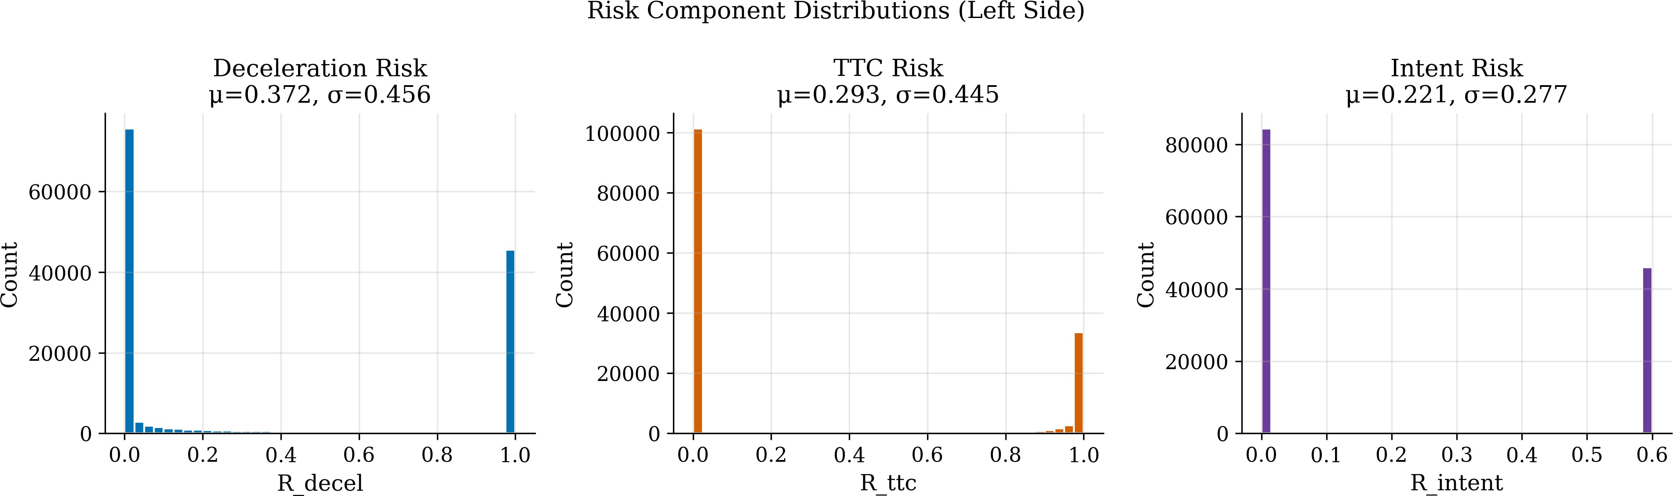
Fig. 3 Distributions of the three CRI risk components. High-risk values are rare, consistent with the 2.37% positive event rate in the simulation.

CRI with Severity Gate
The final Collision Risk Index combines the zone-occupancy probability (Section 4.3), the packet-loss penalty (Section 4.4), and the three risk components (Sections 4.5–4.7):
CRI = clip[0,1](︂P_{gps} · max(R_{decel}, R_{ttc})
    - CAUTION (CRI ≥ 0.30): Vehicle detected in blind spot
    - WARNING (CRI ≥ 0.60): Close proximity or approach
    - CRITICAL (CRI ≥ 0.80): Imminent collision risk
To prevent alerts from flickering on and off, the sys-tem requires 3 consecutive steps above a threshold before upgrading, and a small buffer band (0.05) before downgrading. Left and right sides are monitored inde-pendently. The CRI distribution in Fig. 4 confirms 96.0% of observations remain SAFE.
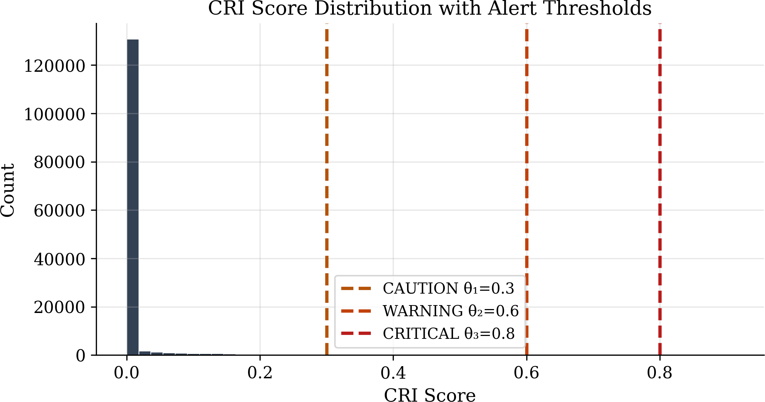
Fig. 4 CRI score distribution across 146,051 timesteps. 96.0% remain in the SAFE region, confirming the severity gate prevents excessive warnings.

Fig. 5 shows the alert activity over the full simu-lation, with spikes corresponding to injected danger scenarios. Fig. 6 illustrates the CRI time-series for a single vehicle pair, showing how the hysteresis mech-anism prevents alert flickering during risk escalation and de-escalation.

- [︁αRdecel + β Rttc + γRintent]︁
- Γplr)︂
(16)

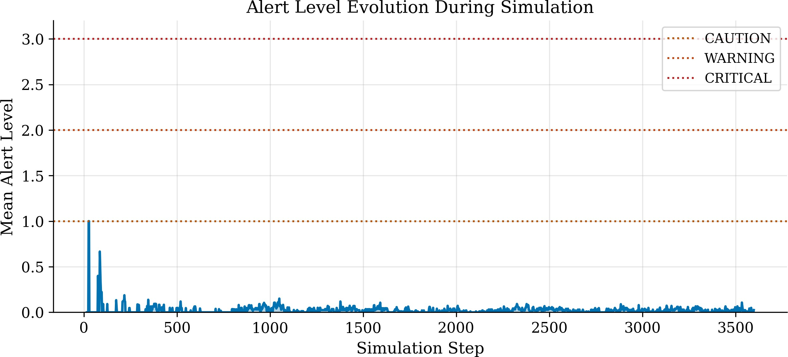
Fig. 5 Mean alert level over the 360-second simulation. Spikes

The max(R_{decel}, R_{ttc}) severity gate in Eq. (16) prevents false alarms from small harmless values adding up by requiring at least one genuinely high danger signal. Optimized weights: α = 0.20, β = 0.80, γ = 0.00.

Alert Levels
The system triggers four alert levels based on CRI:
    - SAFE (CRI < 0.30): No danger detected
correspond to injected danger scenarios (traffic signal violations and narrow road events).

Scenario Modelling
To test the system under realistic danger conditions, two conflict scenarios and a communication failure model were implemented.

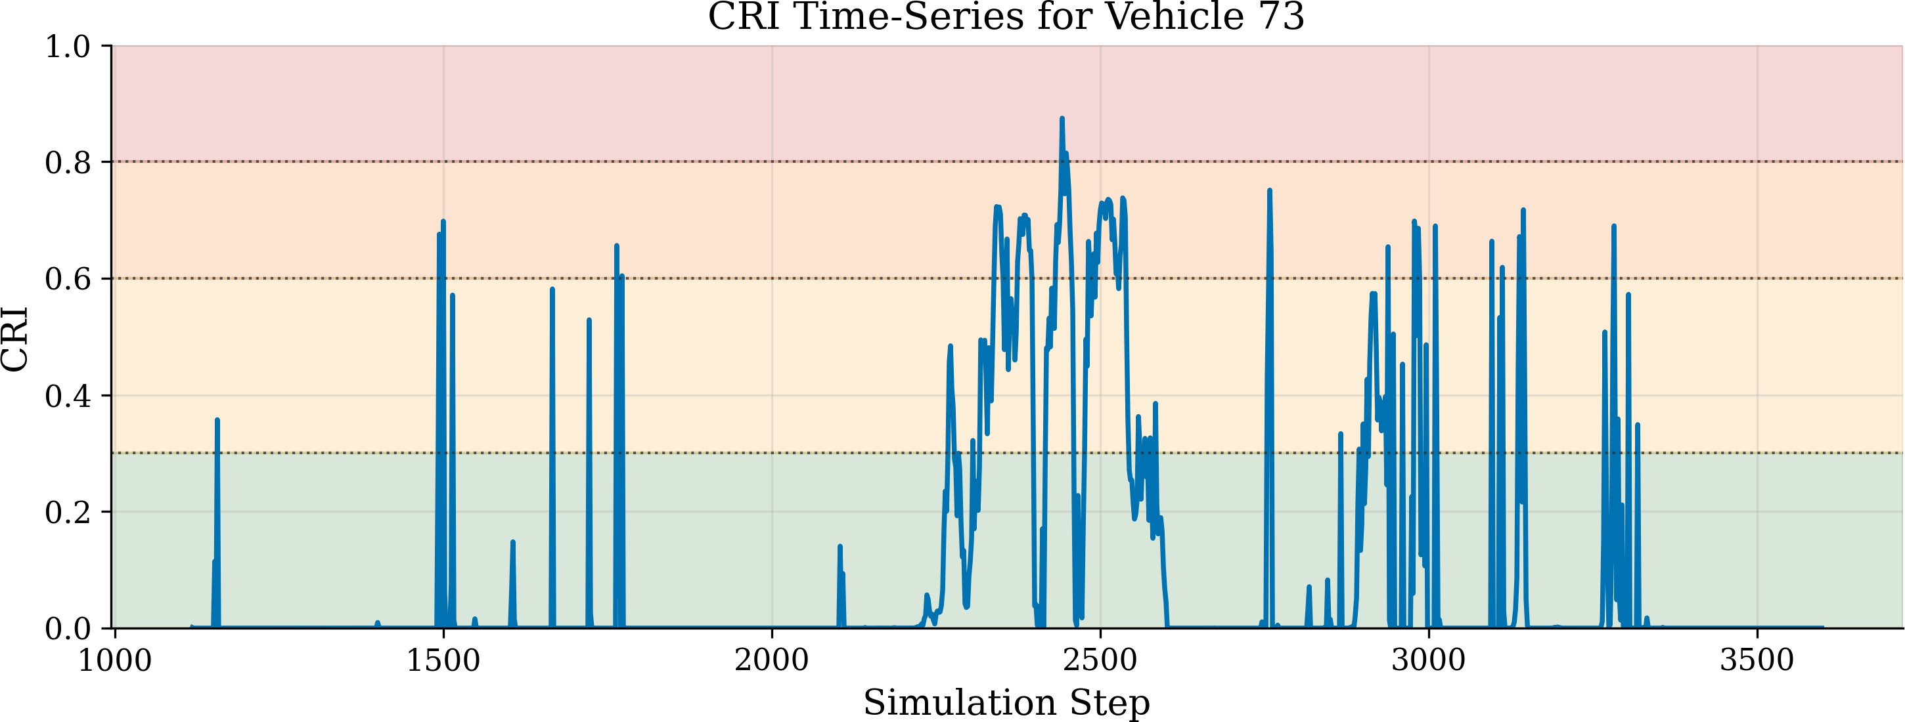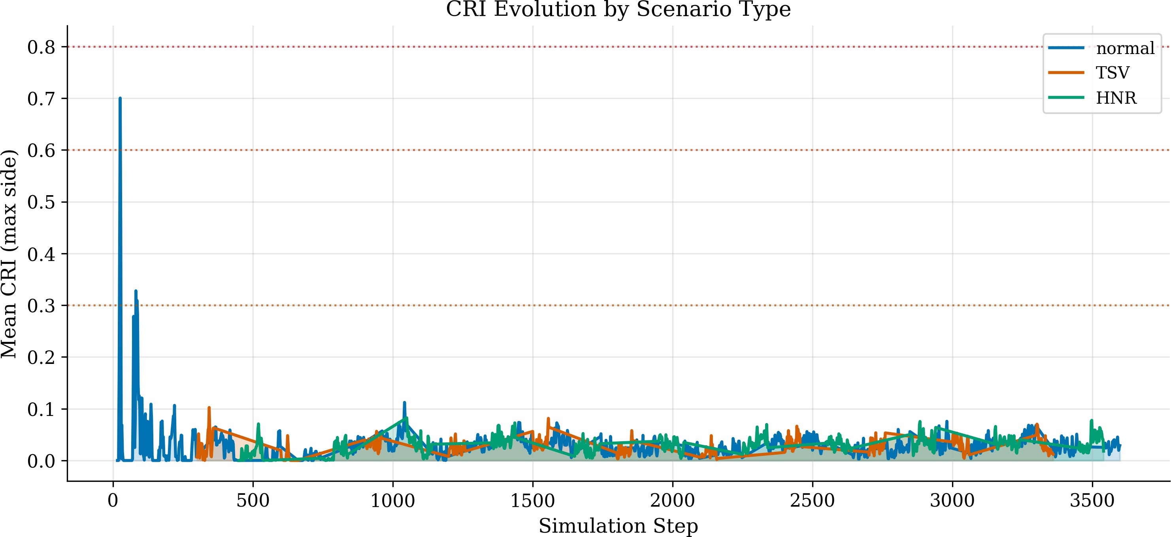

Fig. 6 CRI time-series for a single vehicle showing risk escalation and de-escalation. Horizontal lines indicate alert thresholds: CAU-TION (0.30), WARNING (0.60), CRITICAL (0.80). The hysteresis
requirement (3 consecutive steps) delays alert upgrades, preventing flicker.

Traffic Signal Violation (TSV)
When a vehicle approaches an intersection during a red light, there is a 30% chance it will ignore the signal and continue at full speed. This creates dangerous crossing conflicts that test the system’s ability to detect side-impact collision risks.

Hilly Narrow Road (HNR)
On selected road segments, lane width is reduced to 2.8 metres and road friction is lowered to 0.55 (simulating wet or hilly conditions). Some vehicles (10% probability) attempt aggressive overtaking. This tests the system’s ability to handle reduced braking capability and tight lateral spaces.

Communication Packet Loss
Real-world wireless signals can be interrupted by build-ings, other vehicles, or interference. This is modelled using a Gilbert–Elliott two-state channel [7, 22]: in the good state, only 1% of packets are lost; in the bad state, 50% are lost. The system spends about 9.1% of the time in the bad state, creating realistic multi-packet outages that test the dead-reckoning prediction.
The effect of these scenarios on aggregate risk is shown in Fig. 7. Averaged per simulation step, HNR sustains the highest mean CRI of the three tags (0.032 vs. 0.028 for normal and 0.027 for TSV), consistent with reduced friction and narrow lanes; TSV conflicts are localised to intersection approaches and short-lived, so they barely move the per-step mean even though individual TSV interactions reach CRI values above
0.9. The prominent early spike in the normal series is the fleet-insertion transient at simulation start, not a hazard event.

Fig. 7 Mean CRI per simulation step by scenario type. HNR sustains the highest per-step mean CRI over the run (0.032 vs. 0.028 normal, 0.027 TSV); the early spike in the normal series is the fleet-insertion transient.

Experimental Setup
The experimental setup is described in five parts: the source and structure of the synthetic dataset, the SUMO simulation environment, the road network with its explicit lane-change traffic generator, the reference table of all system parameters, and the configuration of the exploratory XGBoost classifier.

Dataset Description
The dataset used in this work is generated synthetically by the Eclipse SUMO microscopic traffic simulator running on a real-world road network — the Atal Setu corridor in Navi Mumbai, India, extracted from Open-
StreetMap (bounding box lat 18.992–19.003°N, lon 72.846–72.862°E, downloaded on 26 September 2025 under ODbL v1.0). The OpenStreetMap road geometry
is converted into a SUMO network with 539 named road segments, 2,103 lanes, and 501 junctions using netconvert v1.24.0 with UTM zone 43 projection. The simulator is run for 3,600 steps of 0.1 s each (360 s of simulated time) at a BSM update rate of 10 Hz, under a fixed random seed of 42. The simulated vehicle fleet contains three classes (sedans 65%, SUVs 25%, trucks 10%) with realistic acceleration and braking profiles. Three hazard scenarios are tagged in the out-put: Normal traffic (the SUMO default car-following and lane-changing behaviour), TSV — Traffic Sig-nal Violation (some red-light-running vehicles), and HNR — Hilly Narrow Road (reduced friction and tight lateral spaces). A Gilbert–Elliott two-state Markov channel injects realistic packet loss on the V2V link. The resulting dataset contains 146,051 observations, each row consisting of 45 columns: kinematic state, CRI sub-components, packet-loss indicators, alert lev-els for the physics model and two baselines, and the XGBoost prediction. The class composition by sce-
nario tag is Normal = 49.6%, HNR = 31.0%, and

TSV = 19.3%. These are scenario row counts, not positive-event rates — the positive-event rate (kine-matic near-miss or physical collision) is much smaller, 2.37%, across the whole dataset. Prior to analysis the
dataset is passed through an automated integrity audit
(dataset_integrity_audit.py in the repository): it verifies the absence of missing and non-finite values and of duplicated rows, checks per-vehicle timestep monotonicity, applies physical range checks to the prin-cipal kinematic and risk columns, and reports the class proportions of the raw file for reconciliation against the values quoted above. The audit passes on the pub-lished dataset; two deliberate encoding properties (a signed longitudinal gap that is negative while a target is alongside the ego, and a small number of deliberately injected aggressive scenario vehicles above 60 m/s — 44 of 146,051 rows) are documented in the audit report rather than silently accepted.

Simulation Environment
All experiments use Eclipse SUMO running at 10 Hz. The road network is a 539-edge map of the Atal Bridge corridor in Navi Mumbai, India, extracted from Open-StreetMap. The simulation runs for 360 seconds of simulated time and peaks at 163 simultaneous vehi-cles, yielding 146,051 total observations under random seed 42 (deterministic; same seed produces identical telemetry on the same SUMO version).

Road Network and Lane-Change Setup
The Atal Bridge network includes multi-lane roads, controlled intersections, and highway ramps. The traffic generation script forces dense lane-change inter-actions throughout the network using a four-phase route generator. Phase 1, which is the primary source of blind-spot events, populates every multi-lane edge with paired vehicles every 3.0 s of simulated time: a slow leader vehicle is inserted on lane 0 at 30 m from the edge start, travelling at 12 m/s, and an aggres-sive catcher vehicle is inserted on lane 1 at the edge start, travelling at 28 m/s with maxSpeed 35 m/s. The lane assignment alternates per timestep so both left-side and right-side blind-spot configurations are generated. Where three lanes are available, a third truck-type vehicle on lane 2 acts as an occluder for line-of-sight sensing. Phase 2 adds 150 cross-network commuter routes; Phase 3 inserts platoons of six vehi-cles at 0.5 s headway; Phase 4 streams vehicles inward
from every network-boundary edge. SUMO’s built-in LC2013 lateral controller produces the actual lane-change dynamics, with lateral resolution set to 0.8 m and speed deviation 0.1 on each vehicle type. Lane-change events triggered by this combination of forced
insertion patterns and the LC2013 model are what gen-erate the 3,465 positive ground-truth events used to score the CRI.

Parameter Reference Table
The system parameters are listed in Table 2.

Table 2 System Parameter Reference

Parameter | Symbol | Value | Unit
BSM Frequency | 1/∆t | 10 | Hz
Detection Range | Rmax | 300 | m
GPS Uncertainty | σgps | 1.5 | m
Reaction Time | Treact | 1.2 | s
Baseline Friction | µ | 0.70 | –
Lane Width | Wlane | 3.5 | m
Zone Speed Floor | vmin | 2.0 | m/s
Zone Speed Ceiling | vmax | 40.0 | m/s
Critical TTC | TTCcrit | 4.0 | s
Maximum TTC | TTC_{max} | 8.0 | s
Safe Boundary | θ₁ | 0.30 | –
Warning Boundary | θ₂ | 0.60 | –
Critical Boundary | θ₃ | 0.80 | –
Decel. Weight | α | 0.20 | –
TTC Weight | β | 0.80 | –
Intent Weight | γ | 0.00 | –
Brake Decay | Kbrake | 1.50 | –
PLR Penalty | ε | 0.30 | –
Hysteresis Steps | N_{H} | 3 | –
Downgrade Band | δ_{h} | 0.05 | –
Lateral Tolerance | ∆W | 0.5 | m
Low-Speed Guard | vmin,θ | 0.5 | m/s
Good→Bad prob. | pG→B | 0.01 | –
Bad→Good prob. | pB→G | 0.10 | –

AI Model Configuration
An XGBoost classifier [8] serves as an exploratory baseline. Fifteen features are computed from the 5 BSM fields, of which approximately 11 are lin-early independent once correlated pairs (e.g., speed and speed_kmh) are removed. The dataset is heavily skewed: out of 146,051 observations only 54 carry a CRITICAL label, which is a positive rate below 0.04%. Training on the raw distribution would let the classi-fier collapse to “always predict SAFE” and still reach

99.96% accuracy. To prevent that, two training-only augmentations are applied; we state both explicitly because they matter for interpreting the CRITICAL-class results. First, 300 synthetic CRITICAL exemplars, sampled from hand-specified uniform kinematic ranges (generate_critical_scenarios in the repository), are injected into the training partition to give the learn-
ers any CRITICAL signal at all beyond the ∼41 real training rows. Second, SMOTE (Synthetic Minority
Over-sampling Technique) [15] is applied to the train-ing partition: SMOTE picks a minority-class sample, finds its k nearest minority neighbours in feature space, and synthesises a new sample on the line segment con-necting them. The CAUTION class is oversampled to 3,000 rows, WARNING to 2,000 rows, and CRIT-ICAL to 500 rows (from the 341 real-plus-injected rows). The held-out 25% test partition receives nei-ther augmentation, so reported test metrics reflect the true class distribution. We use 5-fold time-series cross-validation for internal stability checks, on top of the 75/25 stratified holdout split.

Results and Analysis

Analysis framework
Because this section contains ten subsections, each answering a different question about the engine, we first state the framework that organises them and the logical relationships between them. The framework is shown as a flowchart in Fig. 8 and summarised subsec-tion by subsection in Table 3. It has five stages, and its shape is not a chain: Stages 1 and 2 are sequential, because nothing can be measured before the ground truth is defined, but Stages 3, 4 and 5 are three inde-pendent interrogations of the Stage-2 result and can be read in any order.
Stage 1 — Validity of the measuring stick (Section 7.1). Defines the two ground-truth sources, Tier 1 (SUMO physical collisions, label-independent) and Tier 2 (kine-matic near-miss proxy), and states exactly what each can and cannot support. Every number in Stages 2–5 is measured against these labels, so nothing downstream is interpretable until this stage is settled.
Stage 2 — How well does the engine detect? (Sections 7.2–7.4). Establishes the headline detection result with confidence intervals and pairwise signifi-cance tests, then shows it is not an artefact of test-set leakage, then displays the full threshold-independent
operating characteristic behind the single AUC figure. This is the claim the remaining three stages interrogate.
Stage 3 — Is a learned model a better choice? (Sections 7.5–7.6). Tests the design decision at the heart of the paper — physics rather than learning — by training one classifier and then three more under identi-cal pre-processing, and by locating the precise obstacle (CRITICAL-class rarity) rather than merely reporting that learning scores lower.
Stage 4 — Does the result survive a change of con-ditions? (Sections 7.7–7.8). Re-measures the Stage-2 result after changing the hazard type and then the ran-dom traffic seed, which separates a genuine property of the engine from a property of one particular simulation run.
Stage 5 — Why does it work, and where does it break? (Sections 7.9–7.10). Attributes the Stage-2 result to the component weights that produce it by varying them one configuration at a time, then maps the parameter envelope within which the result continues to hold.
Read as a whole, the five stages form a single argu-ment: Stage 1 establishes what counts as a correct detection, Stage 2 shows the engine achieves it, Stage 3 shows the obvious alternative does not, Stage 4 shows the achievement is not conditional on one scenario or seed, and Stage 5 shows which weighting choices the result rests on and how far the operating condi-tions can drift before it degrades. The two dashed arrows in Fig. 8 mark the two places where a later stage sends a conclusion back to an earlier one. The Stage-5 ablation is where the published weight configu-
ration (α, β , γ) = (0.20, 0.80, 0) is chosen from among the five candidates, and Section 7.3 is the held-out re-
check that this choice is not an artefact of having seen the evaluation data. The Stage-3 rare-event ceiling is what justifies keeping the Stage-2 physics engine as the sole decision-maker rather than promoting any learned classifier.

Ground Truth Definition
Two complementary ground-truth sources are used. We refer to them as Tier 1 and Tier 2 throughout the paper; the labels refer to the source of the positive label, not to road friction or any other physical quantity.

Tier 1 — SUMO physical collisions (model-independent).
At each simulation step, SUMO’s collision detector reports every pair of vehicles that physically overlap.

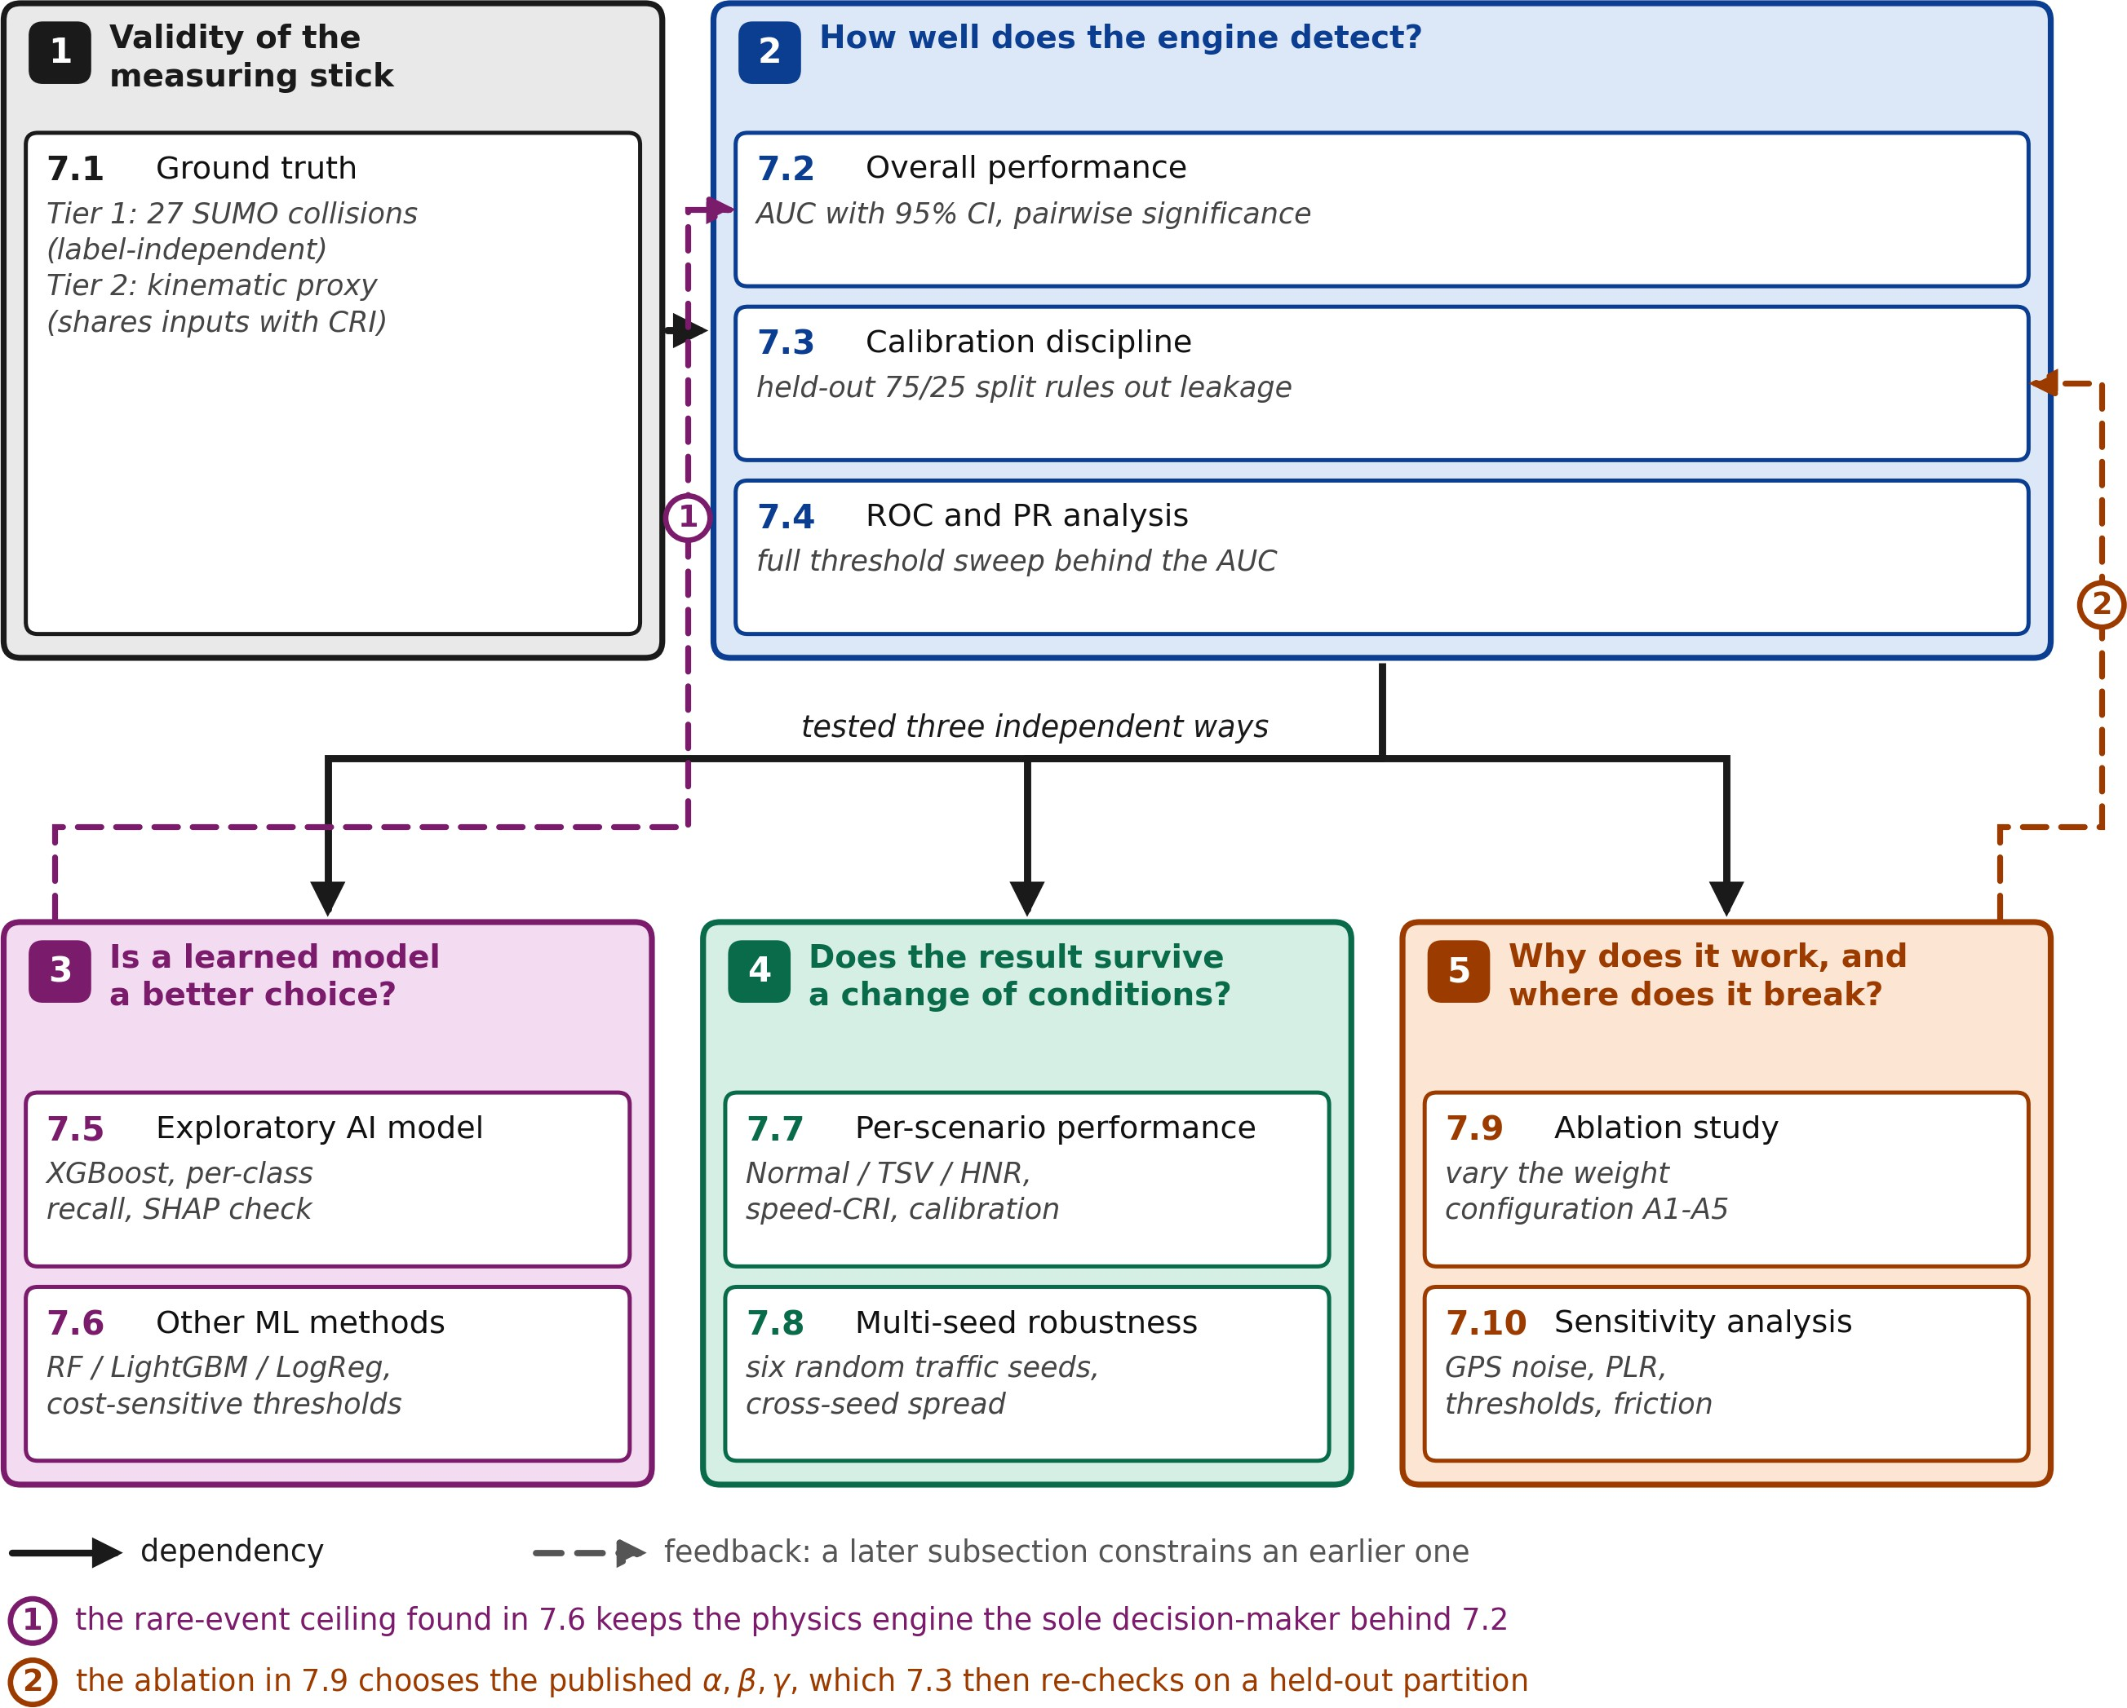

Fig. 8 Analysis framework for Section 7. The ten result subsections are grouped into five stages. Solid arrows are dependencies: Stage 1 defines the ground truth that Stage 2 measures against, and the Stage-2 result then fans out to three independent interrogations — Stages 3, 4 and 5 — which do not depend on one another and may be read in any order. The two dashed arrows are the feedback paths, listed as notes ⃝1 and ⃝2 beneath the diagram: the rare-event ceiling established in Section 7.6 is what keeps the physics engine the sole decision-maker behind Section 7.2, and the ablation of Section 7.9 is where the published weights are chosen, which Section 7.3 then re-checks on a held-out partition.

Both the collider and the victim are flagged as positive for that step. Across the 360 s run there are 27 such collision events. These labels are produced entirely by SUMO’s microscopic dynamics and do not use any quantity computed by the CRI engine. Two qualifica-tions keep this claim honest. First, model-independent here means label-computation independence: the colli-sion labels are never derived from a CRI quantity. The collisions are nevertheless generated by the same sim-ulated traffic process — SUMO’s car-following and lane-change models — whose dynamics are correlated with the gap and TTC quantities the CRI consumes, so the independence is partial rather than absolute; only on-road data or a third-party benchmark would provide a fully external test (see the Limitations in Section 9).
Second, with only 27 positive events the bootstrap con-fidence interval on any AUC is intrinsically wide, and the Tier 1 result should be read as evidence of consis-tency with the proxy-based ranking rather than as a precise effect size.

Tier 2 — Kinematic near-miss proxy.
Physical collisions are extremely rare in any well-behaved simulation, which leaves very few samples for receiver-operating-characteristic estimation. To supplement Tier 1, a deterministic kinematic rule flags additional near-miss events using only quantities present in the BSM. A row is labelled positive when all of the following hold:

Table 3 Function of each Results subsection and its place in the analysis framework of Fig. 8.

Stage Subsection Question it answers Evidence Outcome

    - 7.1 Ground truth Against what labels is a
detection judged correct, and how independent are they?
— Tier 1 (n = 27, label-independent) and Tier 2 (proxy, shares inputs) defined with their
limits stated

    - 7.2 Overall per-formance

2 7.3 Calibration discipline

- 7.4 ROC and PR
analysis
How well does the engine rank risk against each ground truth, and is the margin sig-nificant?
Could the published weights be an artefact of test-set knowledge?

What does the full threshold sweep look like behind the single AUC number?
Table 4 Tier 1 AUC 0.958 [0.944,
0.970]; better than every base-line at p < 0.001

Table 5 No: on the untouched partition they reach Tier 1 AUC 0.941
and Tier 2 0.987, indistinguish-able from a train-only optimum
Figs. 9, 10 AUC ordering of Table 4 repro-
duced; only the physics curve dominates at every operating point; AUPRC 0.677 vs. 0.024
random

- 7.5 Exploratory AI model

- 7.6 Other ML methods

- 7.7 Per-scenario performance
Would a learned classifier do better than the physics engine?

Is that failure specific to XGBoost or inherent to the data?

Does performance depend on the hazard type?
Table 6, Figs. 11–
15

Tables 7, 8,
Fig. 16

Table 9,
Figs. 17, 18
No: Tier 2 AUC 0.772 and 0% argmax CRITICAL recall; SHAP confirms physically sen-sible attributions
Inherent: all four learners reach 0% argmax CRITICAL recall; no threshold is both sensitive and precise
No: ∆AUC ≤ 0.002 across Nor-mal, TSV, HNR

- 7.8 Multi-seed robustness

- 7.9 Ablation study

5 7.10 Sensitivity analysis
Does performance depend on one random traffic pat-tern?
Which weighting choices actually produce the result?

Over what parameter range does the result still hold?
Table 10 No: 0.9954 ± 0.0041 over six seeds; seed 42 is the conserva-tive case
Table 11 γ = 0 is load-bearing: enabling intent at γ = 0.20 costs 44% F1 at the WARNING threshold; A5
selected over A2 on proxy AUC
Fig. 19 Robust to GPS noise ≤ 3.0 m and packet loss ≤ 20%

- the ego speed exceeds 2.0 m/s (filters parked or stationary egos);
- the target lies within the blind-spot zone (in_zone_left or in_zone_right is true);
- either the longitudinal gap is below 1.0 m, or the kinematic TTC proxy TTC_{proxy} = d_{gap}/ max(v_{rel}, 0.5 m/s) is below 2.0 s;
- the relative speed exceeds 0.5 m/s (avoids division-
by-near-zero in the TTC proxy).

The thresholds are not free hyperparameters. The 1.0 m gap is a vehicle-width safety margin (a gap below one vehicle width during a lane-change implies side-swipe contact in the next sample). The 2.0 s TTC threshold corresponds to the imminent-warning band used in the AEB regulatory test protocols [5, 21]. The
0.5 m/s relative-speed guard prevents the proxy from triggering on stationary co-travellers where the TTC denominator would collapse. The 2.0 m/s ego-speed guard mirrors the parameter v_{min} = 2.0 m/s used by the dynamic blind-spot zone (Section 4). Combining
Tier 1 and Tier 2 gives 3,465 positive events on 146,051 observations, a positive rate of 2.37%.

Caveat (acknowledged honestly).
The Tier 2 proxy uses some of the same input quantities (gap, TTC) that the CRI engine consumes. As a result, the Tier 2 AUC measures rank-ordering consistency between the CRI score and the same set of underlying physical signals — it is not an independent validation. The model-independent AUC against the 27 Tier 1 collisions is reported separately throughout this paper; it has wider confidence intervals because of the small sample, but it does not share inputs with the CRI score.

Overall Performance
The system was evaluated over 146,051 observations split by scenario as Normal 49.6%, HNR 31.0%, TSV 19.3% (these percentages are scenario row counts; the positive-event rate is 2.37% across all rows). Perfor-
mance is reported in Table 4 against both ground-truth sources defined above. The order of columns puts the model-independent SUMO-collision metric first, because it is the one that does not share inputs with the CRI score. All AUC values in Table 4 carry 95% confi-dence intervals computed by stratified bootstrap [25] over 2,000 resamples of the full 146,051-row evalua-tion set (the 75/25 split is used only for the calibration check of Section 7.3 and the classifier experiments). Pairwise differences in AUC between the physics model and each baseline are tested by paired bootstrap on the same 2,000 resamples, so the smallest resolv-
able two-sided p-value is 0.001 (significance codes: ∗
p < 0.05, ∗∗ p < 0.01, ∗∗∗ p < 0.001, two-sided).
The physics model is statistically better than every
baseline on both ground-truth definitions, and the physics-model ranking is preserved on Tier 1: the proxy is not inverting the headline conclusion. The relative gap is larger on Tier 1 (Physics − TTC = +0.17 AUC)
than on Tier 2 (Physics − TTC = +0.10 AUC), which
is the opposite of what one would expect if the pub-lished numbers were purely a self-consistency artefact. AUPRC for the physics model is 0.677 on the proxy — 28× the random-baseline AUPRC of 0.024 driven by the 2.37% positive rate.

Calibration Discipline Verification
A reasonable concern with the headline number is whether the CRI weights α = 0.20, β = 0.80 were selected with knowledge of the test data — in other words, whether they are fitted on the test set rather than learned from training. To rule this out we re-ran the weight selection under a strict 75/25 stratified train/test split (random seed 42), so that no part of the held-out test set is visible during weight selection. The grid search swept α ∈ [0.10, 0.90] in 0.05 steps
with α + β = 1 and γ fixed at zero. Both AUC and
F1 selection criteria identified the same train-optimal weights, α⋆ = 0.90, β ⋆ = 0.10 (a different point from the published configuration). We then evaluated both
weight settings on the same untouched test partition. The results are in Table 5.
The published weights generalise to the held-out test partition at proxy AUC = 0.987 and Tier 1 AUC
= 0.941; only 7 of the 27 collision events fall in the
test partition, so the Tier 1 interval is necessarily wide.
The headline result is therefore not a product of test-set leakage. We keep the published weights α = 0.20, β = 0.80 as the production configuration because (i) on the label-independent Tier 1 ground truth the two
configurations are statistically indistinguishable (their bootstrap CIs overlap almost entirely), (ii) the pub-lished weights perform marginally better there (0.941 vs. 0.939), and (iii) re-running the simulation under the alternative weights does not visibly change the alert behaviour in the per-vehicle time-series plots. On the Tier 2 proxy the train-optimal weights are genuinely (if slightly) stronger, as Table 5 shows.

ROC and PR Analysis
The purpose of Fig. 9 is to compare threshold-independent detection quality across all four methods on one axis system [23]: each curve traces the true-positive/false-positive trade-off as the alert threshold sweeps its range. The curves are computed on the Tier 2 kinematic proxy across the full 146,051-row evaluation set. The Tier 2 ranking matches Table 4:
physics model at AUC = 0.987, TTC kinematic base-line at 0.889, static box baseline at 0.874, and the
exploratory XGBoost classifier at 0.772. Against the 27

Table 4 Performance with 95% bootstrap CIs and pairwise significance vs. Physics. Tier 1 (SUMO collisions, n = 27) is label-independent (its labels use no CRI quantity; see Section 7.1 for the qualifications); Tier 2 (kinematic proxy) shares inputs with the CRI score and is reported only for completeness.

Method | Tier 1 AUC [95% CI] | vs. Phys. | Tier 2 AUC [95% CI] | vs. Phys.
Physics (CRI) | 0.958 [0.944, 0.970] | — | 0.987 [0.986, 0.988] | —
TTC kinematic | 0.788 [0.692, 0.876] ∗∗∗ 0.889 [0.882, 0.895] ∗∗∗
Static box | 0.766 [0.673, 0.856] ∗∗∗ 0.874 [0.867, 0.880] ∗∗∗
XGBoost (exploratory) | 0.779 [0.714, 0.845] ∗∗∗ 0.772 [0.767, 0.779] ∗∗∗

Table 5 Held-out test performance under the published weights vs. train-only-optimal weights. Both configurations generalise comfortably; the published weights are slightly better on Tier 1, the train-optimal weights are slightly better on Tier 2.

Weights (α, β ) | Tier 1 AUC [95% CI] | Tier 2 AUC [95% CI] | F1 @ 0.60 | Test rows
Published (0.20, 0.80) | 0.941 [0.896, 0.979] | 0.987 [0.985, 0.989] | 0.607 | 36,513
Train-optimal (0.90, 0.10) | 0.939 [0.896, 0.976] | 0.993 [0.992, 0.994] | 0.657 | 36,513

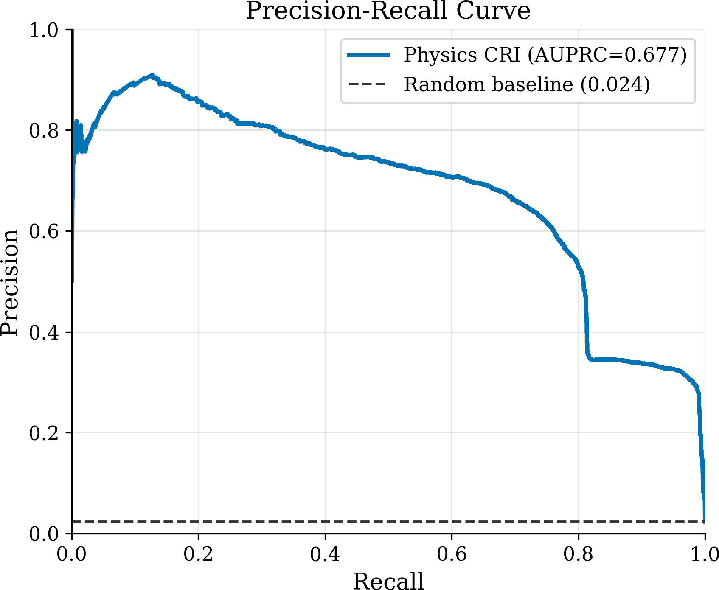
Tier 1 SUMO collisions, the physics model achieves AUC = 0.958 with 95% CI [0.944, 0.970]; as noted
in Section 7.2, the gap to every baseline is wider on
Tier 1 than on Tier 2, the opposite of what an input-overlap artefact would produce. The physics model also achieves an AUPRC of 0.677 on the proxy, far above the random baseline of 0.024 driven by the 2.37% positive rate. Fig. 10 shows the precision-recall curve, which is the more informative view when positive events are this rare and ROC-AUC can be misleadingly optimistic [24]: it reports, at every recall level, what fraction of raised alerts would actually correspond to true events.

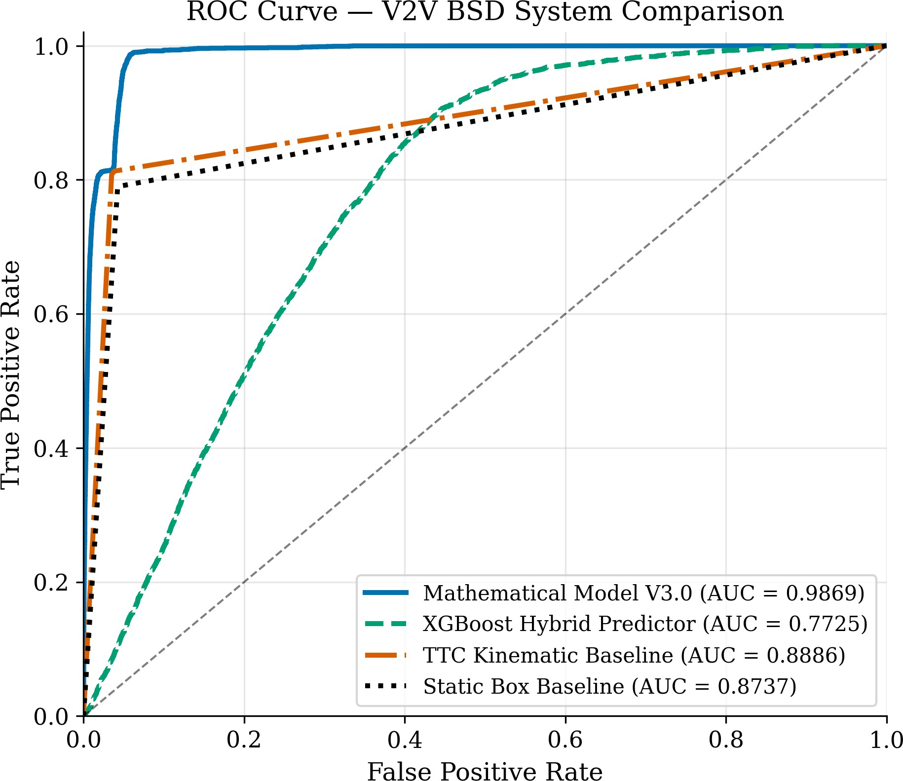
Fig. 10 Precision-Recall curve (AUPRC=0.677 vs. 0.024 random baseline).

Fig. 9 ROC curves for four detection methods.

Exploratory AI Model Results
The XGBoost classifier is included as an exploratory learning-based baseline rather than a proposed deploy-ment component. On the Tier 2 kinematic proxy it scores AUC = 0.772 (below both TTC and Static box, see Table 4); on the Tier 1 model-independent ground truth it scores AUC = 0.779, statistically indis-tinguishable from the two kinematic baselines (the three confidence intervals overlap almost entirely). On the per-class breakdown (Table 6) the classifier detects
CAUTION (64% recall) and WARNING (59% recall)

events but fails entirely on the CRITICAL class under the default argmax decision rule (0% recall, 13 test samples). The failure is systematic rather than statis-tical: five-fold time-series cross-validation also yields 0% CRITICAL recall across all folds, and Section 7.6 shows that Random Forest, LightGBM, and Logistic Regression all hit the same wall under identical pre-processing. The purpose of the confusion matrix in Fig. 11 is to show not merely that argmax CRITI-CAL recall is zero but where the CRITICAL mass is absorbed — into the adjacent WARNING and CAU-TION rows rather than into SAFE — and how the minority classes trade precision against recall.
Fig. 12 reports the XGBoost gain-based split con-tribution of each of the 15 features — the loss reduction attributable to splits on that feature, normalised across the ensemble. Because the paper also reports SHAP attributions, we deliberately avoid the looser term “fea-ture importance” and reserve attribution language for the SHAP analysis below; the gain statistic is a model-internal training quantity, not a per-sample explanation. The strongest split contributions come from braking
dynamics (decel = 0.35) and gap distance (max_gap
= 0.14). The purpose of Fig. 13 is to expose redun-dancy in the input representation before any attribution
is interpreted: the 15 input features include four per-fectly correlated pairs (speed/speed_kmh, rel_speed/ closing_speed, accel/abs_accel, decel/is_braking), so the effective feature count is approximately 11 unique signals, and contribution mass reported for one mem-ber of a correlated pair should be read as shared with its twin.

Table 6 AI Model Class Performance

Class | Prec. | Recall | F1 | Support
SAFE | 1.00 | 0.81 | 0.90 | 35,047
CAUTION | 0.12 | 0.64 | 0.20 | 907
WARNING | 0.11 | 0.59 | 0.19 | 546
CRITICAL | 0.00 | 0.00 | 0.00 | 13

SHAP-based feature attribution
The gain-based split statistic reported in Fig. 12 mea-sures how often each feature is used to split a tree node weighted by the loss reduction it produces, which is a model-internal quantity. To produce a per-sample, model-agnostic measure of feature contribution we additionally computed Shapley Additive exPlanations

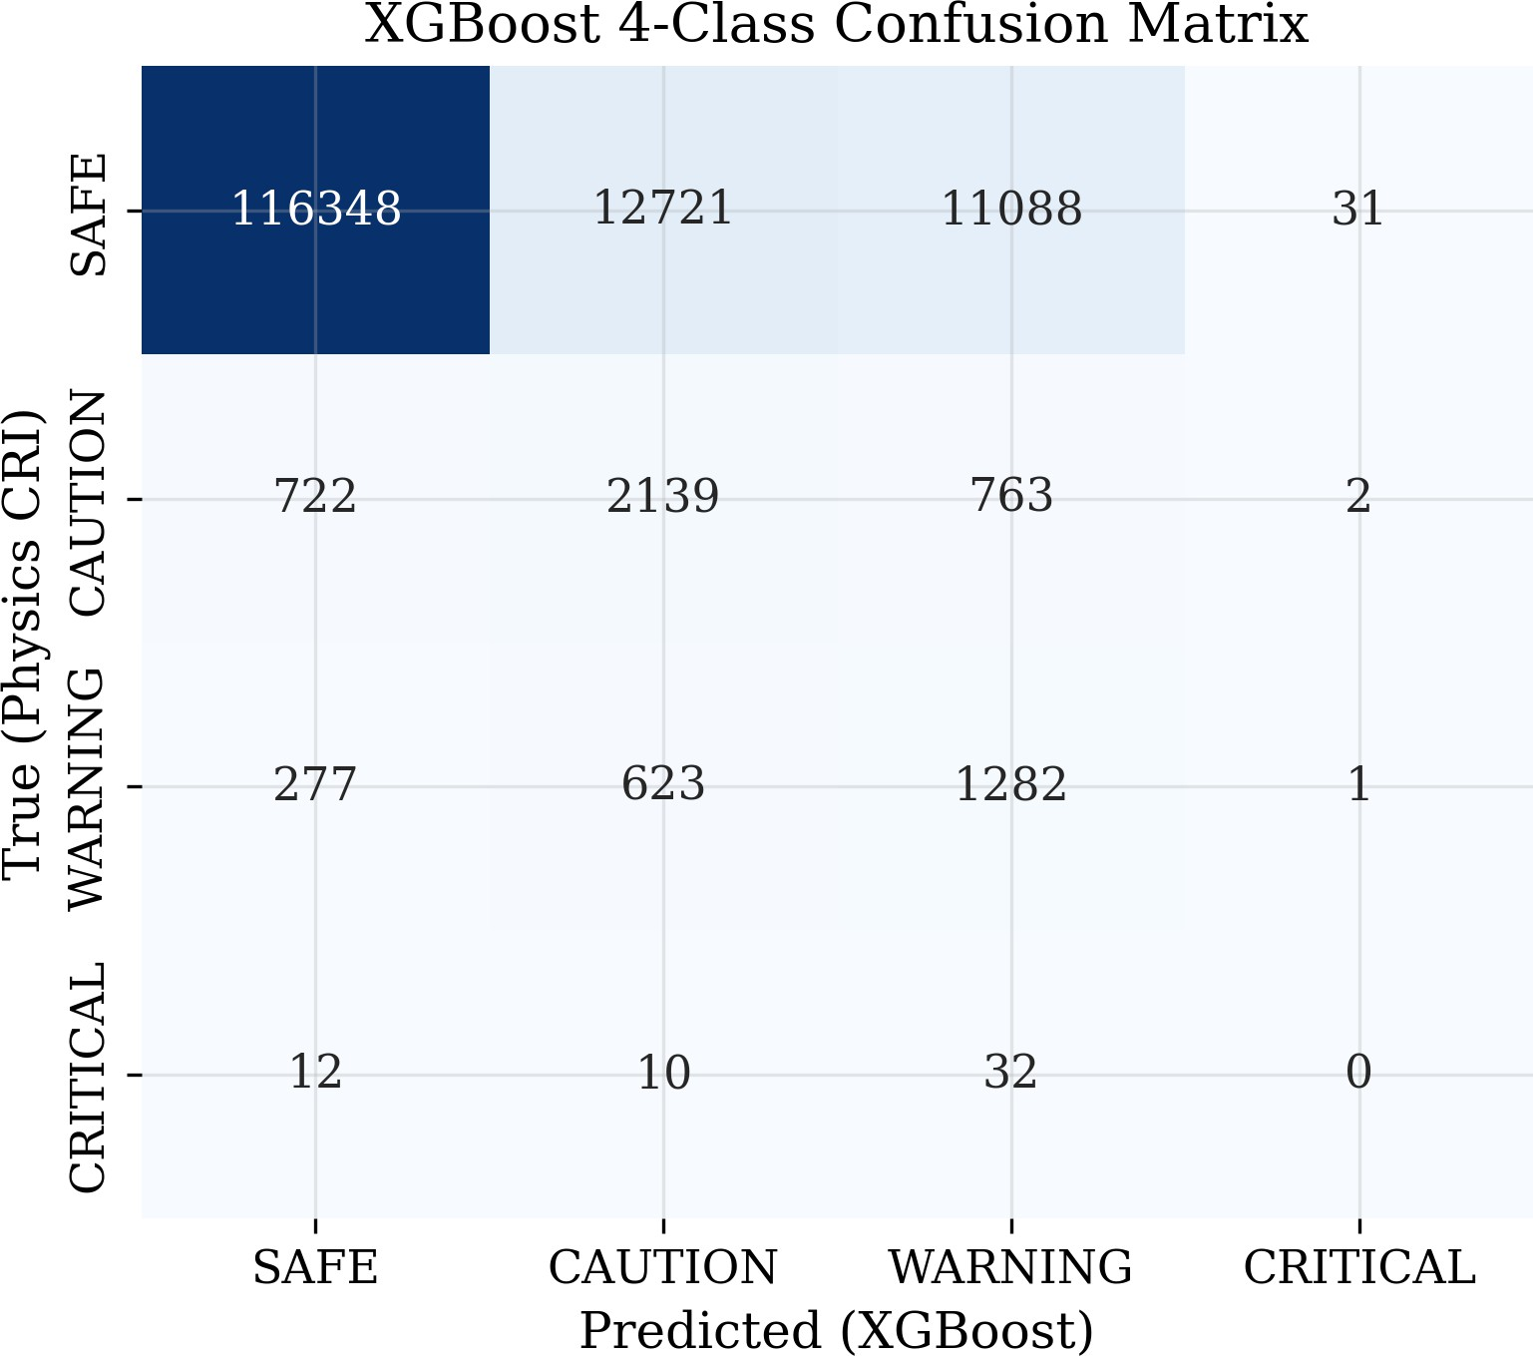
Fig. 11 Four-class confusion matrix: XGBoost predictions vs. physics-model CRI labels. CRITICAL detection fails due to extreme class rarity (54 total samples).
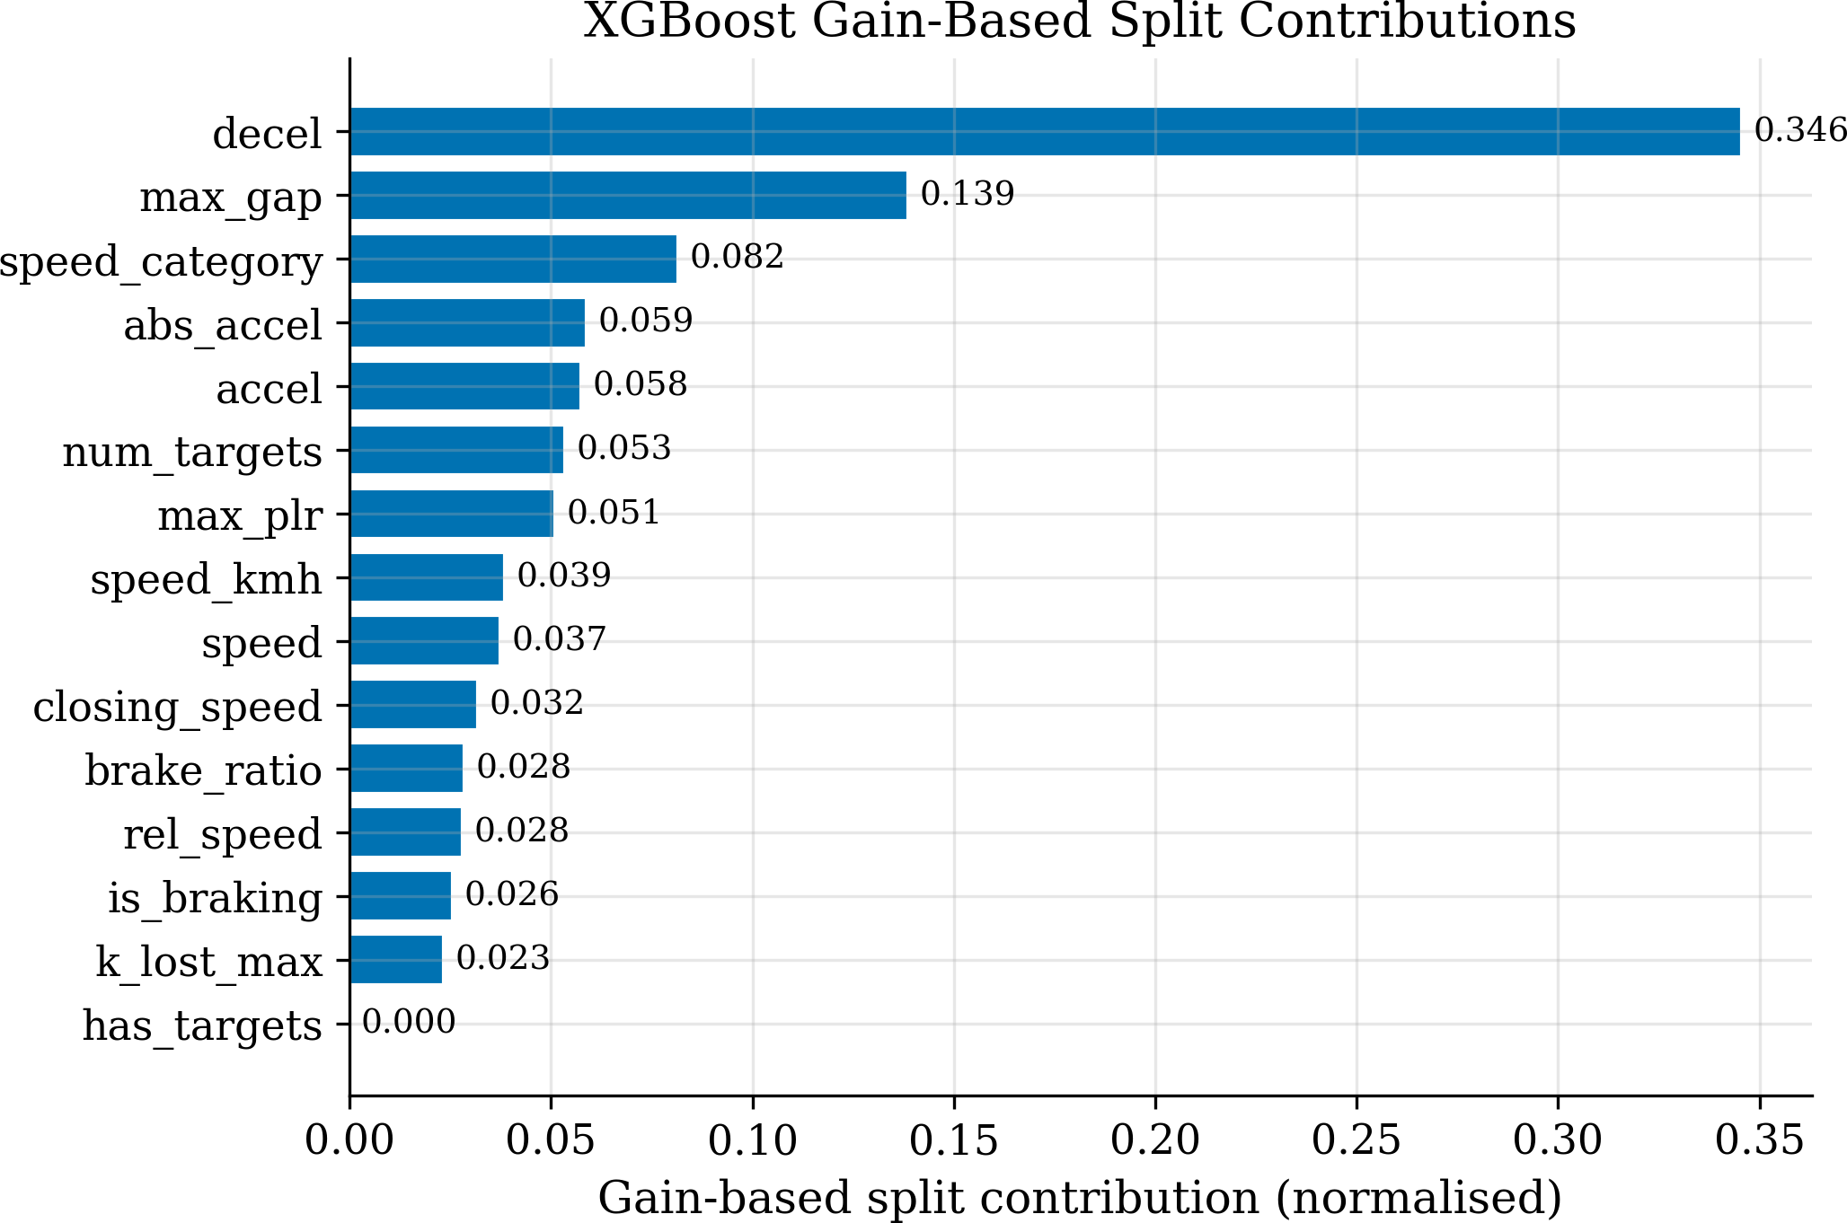
Fig. 12 XGBoost gain-based split contributions (15 features). Decel-eration and gap distance dominate. Scenario labels are excluded from the feature set.

(SHAP) values [18] on a stratified 3,804-row sample using the TreeExplainer for XGBoost. The two SHAP figures serve distinct functions. The beeswarm sum-mary (Fig. 14) shows, for every sample in the SHAP set, both the magnitude and the direction of each fea-ture’s contribution to the CRITICAL log-odds, making systematic physical patterns visible at a glance. The dependence plot (Fig. 15) isolates a single feature and reveals whether its marginal effect is monotone and physically plausible, including its interaction with the most-related second feature.
The gain-based ranking (Fig. 12) and the SHAP ranking agree on the most-impactful features but in a slightly different order: SHAP places max_gap first, then num_targets, max_plr, speed; gain places

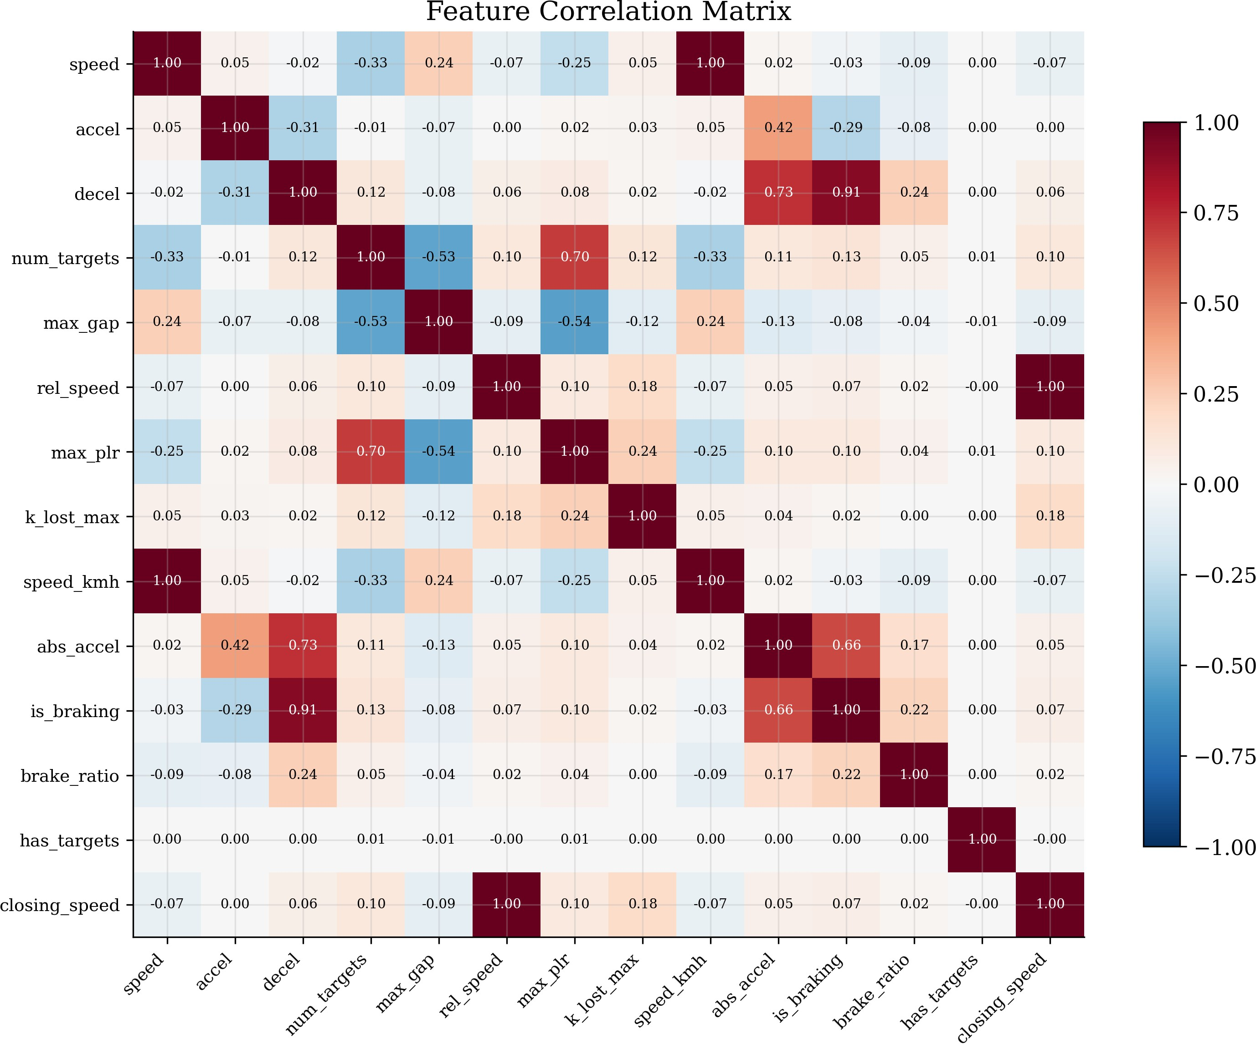

Fig. 13 Feature correlation heatmap, used to identify redundant inputs before interpreting any attribution. Notable redundancies include speed/speed_kmh (r = 1.0) and rel_speed/closing_speed
(r = 1.0), suggesting potential for feature set reduction.

decel first followed by max_gap. The two views are complementary — gain measures the model’s reliance on a feature across all training samples; SHAP measures the per-sample contribution to spe-cific predictions. The fact that the two top features by SHAP (max_gap, num_targets) are also the inputs the physics CRI engine treats as primary — gap dis-tance and target presence — is reassuring from an interpretability standpoint.
A fair question is whether SHAP output is mean-ingful for a classifier whose argmax decision never selects the CRITICAL class (Table 6). SHAP values are computed on the model’s continuous CRITICAL log-odds, not on the thresholded argmax label, and that same continuous score attains a CRITICAL-binary ranking AUC of 0.900 (Table 7) and recovers 11 of the 13 test CRITICAL events at a recall-priority screen-ing threshold (Table 8) — so the attribution explains a score that does carry CRITICAL-relevant signal, even though that signal cannot be converted into a usable detector (Section 7.6). We accordingly present SHAP strictly as an interpretability check on the exploratory learners; no decision of the deployed physics engine rests on it, and the SHAP output makes no claim about the physics engine’s validity.

Comparison with Other ML Methods
A natural question after observing the XGBoost result is whether the underperformance is specific to gradi-ent boosting or whether any data-driven classifier hits

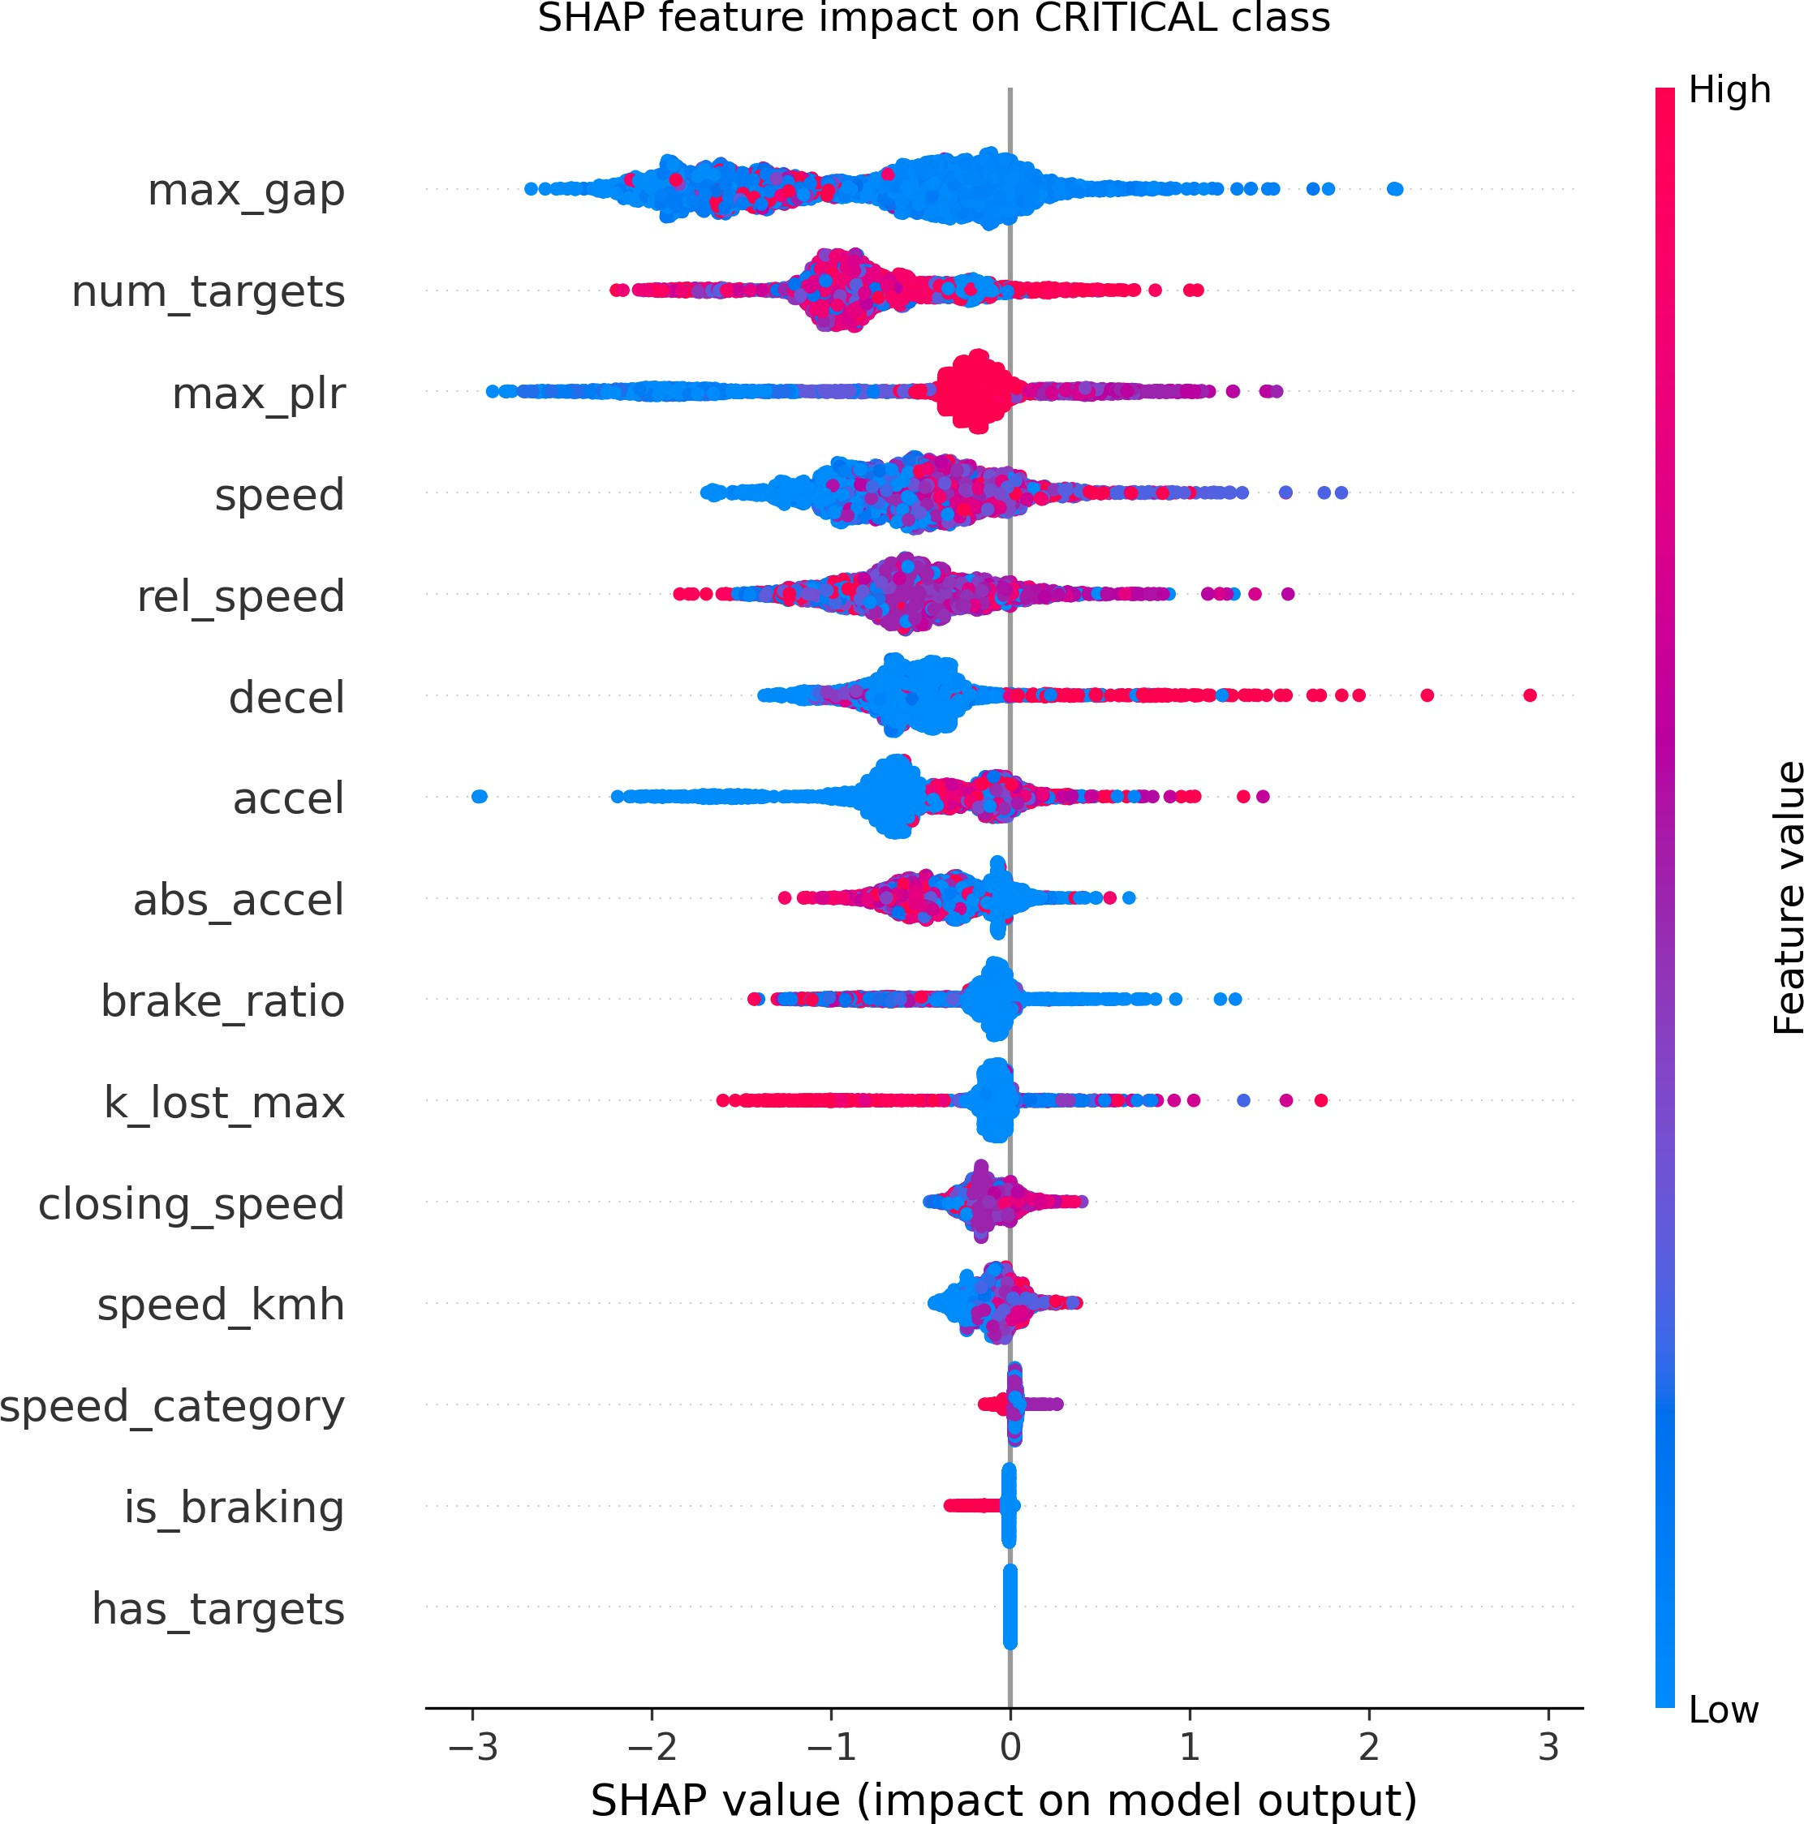
Fig. 14 SHAP beeswarm summary for the CRITICAL class pre-dictions. Each dot is one sample; horizontal position is the SHAP value (impact on the CRITICAL log-odds); colour encodes the fea-ture value (red = high, blue = low). max_gap carries the largest
mean |SHAP| magnitude, closely followed by num_targets, and
the directionality is the physically expected one: small gaps push the
prediction toward CRITICAL.

the same wall. To answer this we trained three addi-tional classifiers on the same 15-feature table, the same train/test split, and the same SMOTE pre-processing as the XGBoost model: a Random Forest with 200 trees and balanced class weights, a LightGBM gradient-boosting classifier matched to the XGBoost hyperpa-rameters, and a multinomial Logistic Regression with standardised inputs. Table 7 reports macro-OvR AUC, CRITICAL-binary AUC, macro F1, and CRITICAL recall on the held-out test set.
The three additional classifiers all sit in the same performance band as XGBoost, and all four fail iden-tically on the CRITICAL class under the argmax rule. (The XGBoost row in Table 7 is retrained inside the same harness as the other three learners for strict com-parability, so its per-class numbers differ marginally from the exported exploratory model of Table 6; both fits share the same features, split, and augmentations.) None of the four recovers a CRITICAL sample in the held-out test set under argmax — not because the algo-rithms are incapable but because there are only 41 real CRITICAL training rows after the stratified split (aug-mented with 300 hand-specified synthetic exemplars and SMOTE-expanded to 500, Section 6.5). With this

Table 7 Held-out test performance of four data-driven classifiers under identical preprocessing. All four models exhibit zero CRITICAL recall under the default argmax decision rule (see Table 8 for tuned-threshold operating points), confirming that the rare-event ceiling is a property of the data distribution rather than a particular classifier choice.

Classifier | Macro AUC | CRITICAL AUC | Macro F1 | CRITICAL Recall
XGBoost | 0.921 | 0.900 | 0.304 | 0.00
Random Forest | 0.912 | 0.894 | 0.357 | 0.00
LightGBM | 0.906 | 0.869 | 0.321 | 0.00
Logistic Regression | 0.850 | 0.757 | 0.304 | 0.00

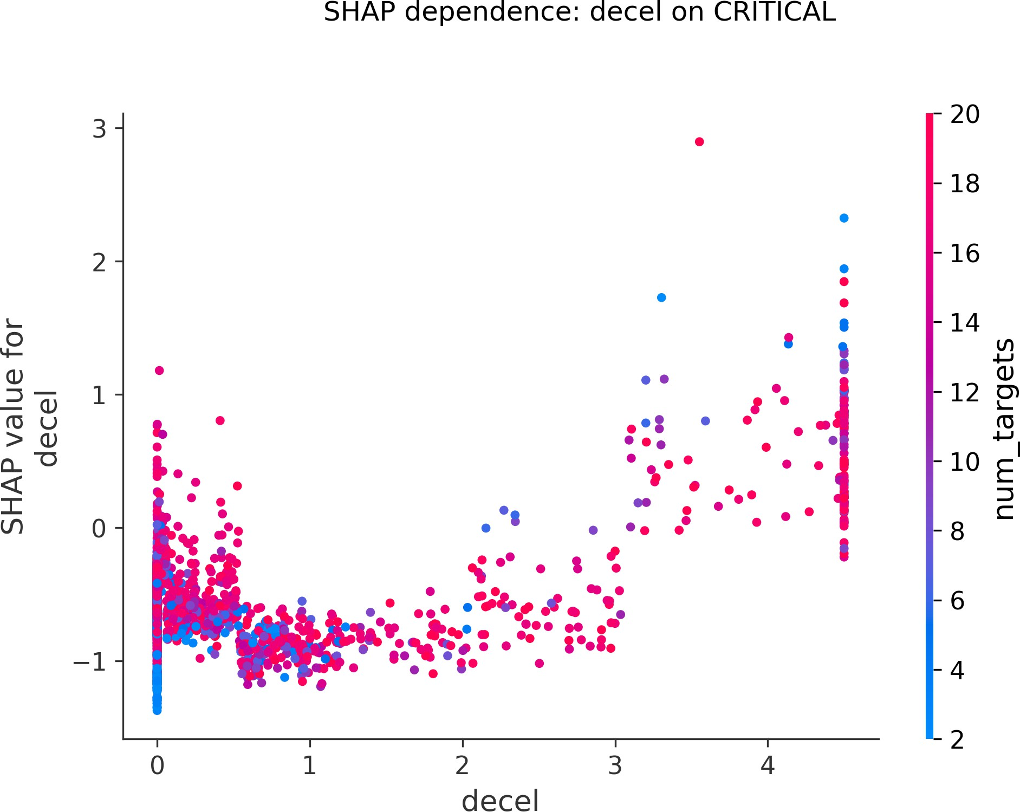
Fig. 15 SHAP dependence plot for decel on the CRITICAL class. Increasing deceleration consistently increases the predicted CRIT-ICAL probability; the vertical spread at each decel value reflects interaction with the second most-related feature, which SHAP selects automatically.

little genuine signal, no classifier can confidently dis-tinguish the CRITICAL region from the WARNING region.

Cost-sensitive operating points.
Because a 0% recall figure invites the objection that it is merely an artefact of the argmax decision rule, we quantify exactly how much of it is. For each classi-fier a decision threshold on the continuous CRITICAL probability was tuned on a validation split carved out of the training partition (synthetic CRITICAL rows are excluded from threshold tuning so the threshold reflects the real data distribution), frozen, and only then applied to the untouched test set. Table 8 reports two operating points per classifier. At the F1-optimal threshold, test recall remains zero for the three tree-based learners; Logistic Regression reaches recall 0.54
there, but only at a precision of 0.001 (F1 = 0.002), i.e., its threshold already behaves like a screening
rule. At a deliberately recall-priority screening thresh-old (chosen to reach 80% validation recall), XGBoost recovers 11 of the 13 test CRITICAL events (recall 0.85) — direct evidence that the continuous score ranks CRITICAL events far above the general pop-ulation, consistent with its 0.900 CRITICAL-binary AUC — but at a precision of 0.002, i.e., roughly 500 false alarms per true event, with 15% of all timesteps flagged. The purpose of Fig. 16 is to show the complete achievable precision-recall frontier for the CRITICAL class on the held-out test set: no threshold exists at which any of the four learners is simultaneously sen-sitive and precise at the 0.036% prevalence. This is the quantitative form of the conclusion above: the learners carry genuine CRITICAL-relevant signal but cannot convert it into a deployable detector at this prevalence, which is precisely why the physics engine remains the sole decision-maker. The path to better data-driven rare-event detection is not a different clas-sifier or threshold but more CRITICAL training data, which requires either much longer simulation runs or controlled real-world data collection.

Per-Scenario Performance
To verify the system works across different hazard types, AUC was computed separately for each sce-nario (Table 9). The narrow spread (∆AUC ≤ 0.002) confirms the system is robust across different traffic conditions.
Fig. 17 plots ego speed against the per-step max-imum CRI for a 5,000-row stratified sample, colour-coded by scenario. Its purpose is diagnostic: it checks that the risk surface is driven by interaction geometry rather than by ego speed alone. Elevated CRI values occur across the whole ego-speed range — including a dense near-standstill column in which a station-ary or queued ego is approached by faster traffic — while above roughly 35 m/s the CRI is essentially zero, because free-flow speeds in this network occur

Table 8 Cost-sensitive CRITICAL operating points on the held-out test set (13 CRITICAL events in 36,513 rows). Thresholds are tuned on a validation split of the training partition and frozen before test evaluation. The screening point deliberately trades precision for recall.

Classifier | Argmax recall | F1-opt. recall | Screening recall | Screening precision | Alarm rate
XGBoost | 0.00 | 0.00 | 0.85 | 0.0020 | 15.1%
LightGBM | 0.00 | 0.08 | 0.62 | 0.0019 | 11.3%
Random Forest | 0.00 | 0.00 | 0.85 | 0.0016 | 18.4%
Logistic Regression | 0.00 | 0.54 | 1.00 | 0.0007 | 51.3%

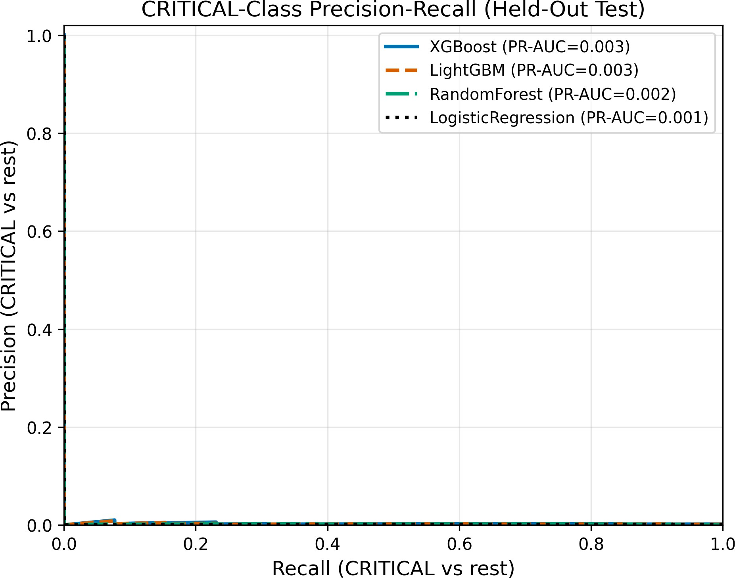
lower AUC. All results reported in prior sections use seed 42 as the conservative baseline.

Table 9 Per-Scenario AUC (Physics Model)

Scenario | AUC | n | Positives
Normal traffic | 0.9874 | 72,494 | 1,619
TSV | 0.9877 | 28,246 | 653
HNR | 0.9857 | 45,311 | 1,193

Fig. 16 Precision-recall curves for the binary task CRITICAL vs. rest on the held-out test set. All four learners hug the precision floor at every recall level: at a prevalence of 13 positives in 36,513 rows, genuine ranking signal (CRITICAL-binary AUC up to 0.900) does
Table 10 Multi-Seed Results (N = 6). Each cell is the Tier 2 proxy AUC as a single-point estimate per seed; the seed-42 value 0.9869 is the same quantity reported rounded as 0.987 in Table 4. The cross-seed standard deviation σ = 0.0041 quantifies stability of the simulation pipeline; it is not a
substitute for the model-independent Tier 1 evaluation.

not translate into usable precision at any threshold. | Metric | Physics (V3.0) | XGBoost
 | Seed 42 (primary) | 0.9869 | 0.7725
only with large headways. HNR rows reach the ele- | Seeds 10–50 (mean) | 0.9971 ± 0.0007 | 0.8985 ± 0.0095
vated band at every speed, consistent with the longer | All 6 seeds | 0.9954 ± 0.0041 | 0.8775 ± 0.0520
stopping distances (reduced friction) that drive R_{decel}.
Fig. 18 serves a different function: it is a reliability

diagram that bins the predicted CRI and plots the observed positive fraction in each bin, testing whether the CRI behaves not only as a ranking score but as an approximately calibrated probability — points near the diagonal mean that a CRI of 0.6 corresponds to roughly a 60% empirical event frequency in that bin.

Multi-Seed Robustness
To confirm results are not dependent on a single ran-dom traffic pattern, the simulation was repeated with six random seeds: the primary seed 42 (used through-out this paper) plus five additional seeds (Table 10). Seed 42 produces the most challenging traffic mix (highest proportion of dense interactions near the Atal Bridge merge zones), which accounts for its slightly

Ablation Study
Five configurations were tested (Table 11); F1 values are reported at the WARNING (0.60) and CRITICAL (0.80) thresholds. Including intent (γ = 0.20, A3/A4) without turn signals causes a 44% F1 drop at the WARNING threshold, validating γ = 0. F1 at the 0.80 threshold is small for every configuration by construc-
tion: the severity-gated CRI exceeds 0.80 on only 54 of 146,051 rows against 3,465 proxy positives, so the CRITICAL threshold operates at precision 0.80 and recall 0.012 (A5, full evaluation set) — it is delib-erately reserved for unambiguous imminent-collision
geometry rather than tuned for F1. (These values cor-rect the pre-revision table, which had reported F1(0.80) from an inconsistent earlier evaluation; the corrected

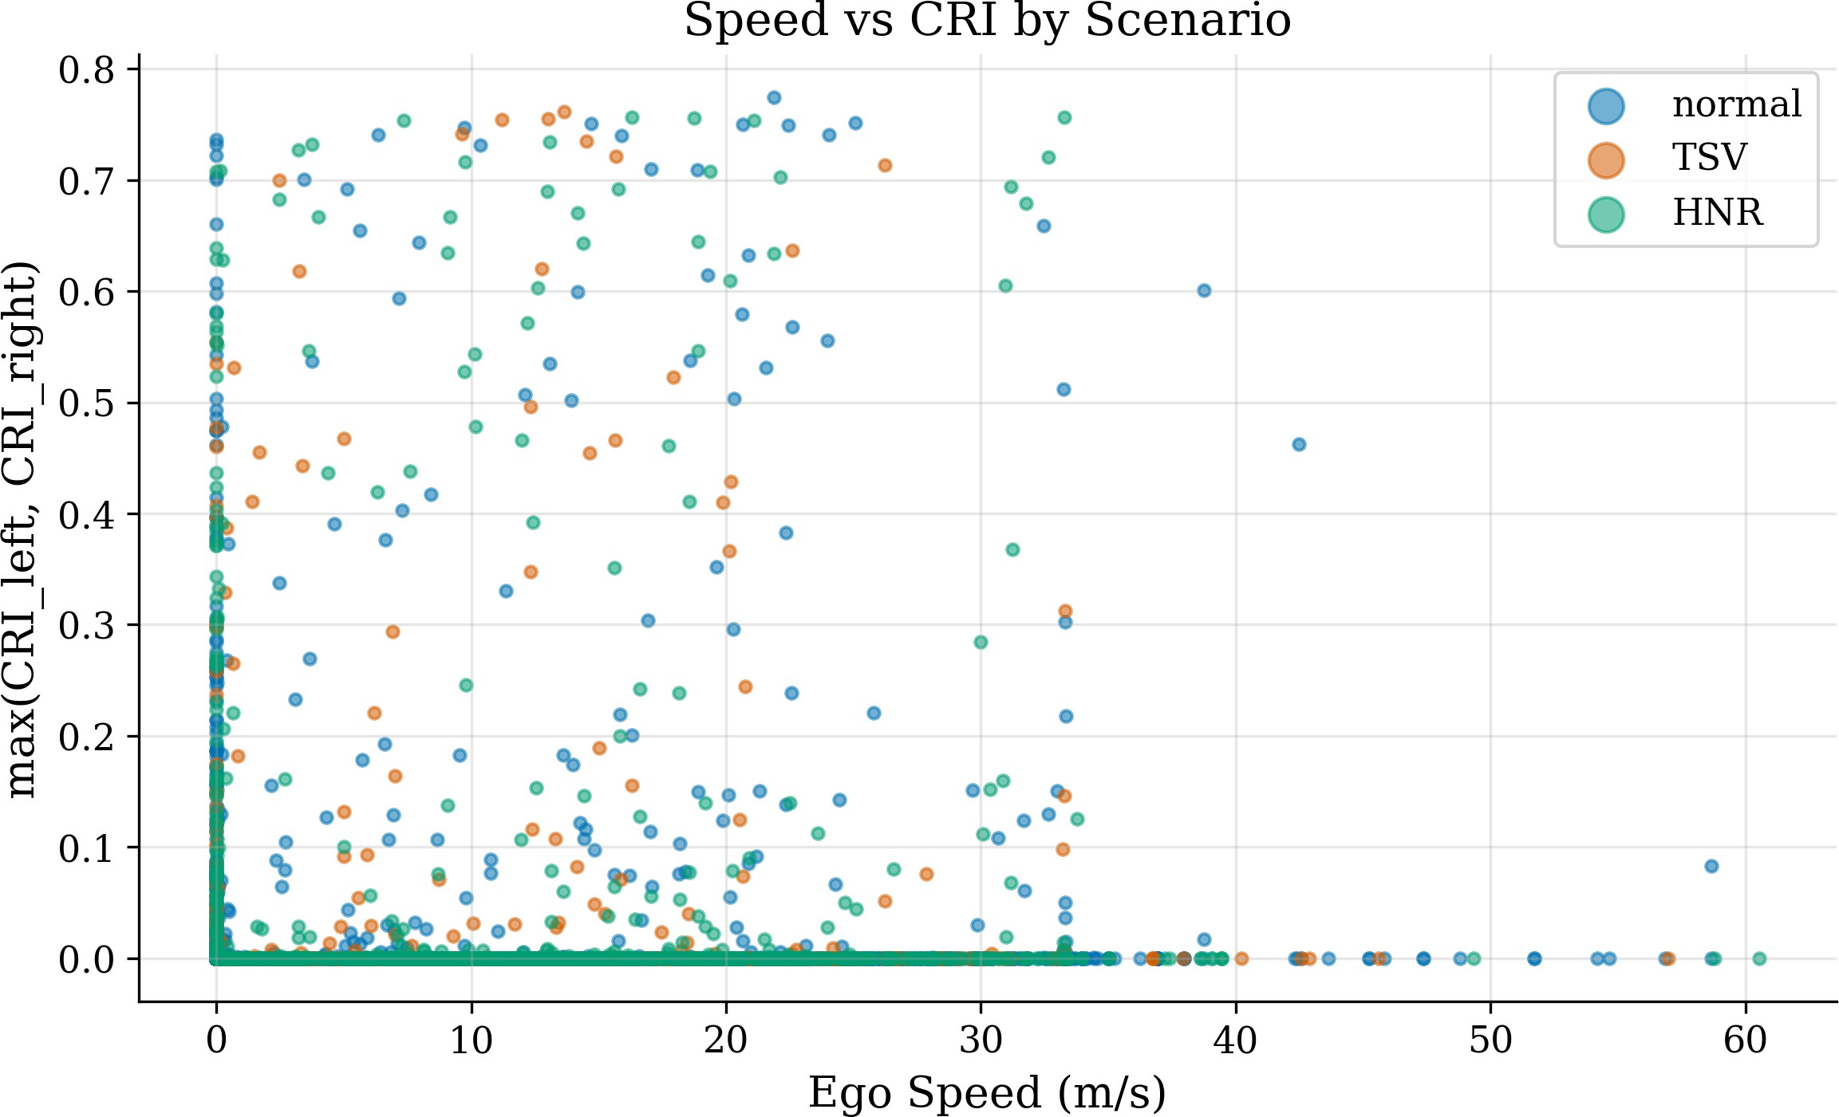
Fig. 17 Ego speed vs. maximum CRI, colored by scenario type (5,000 sampled rows). Elevated-CRI points occur across the whole ego-speed range; HNR rows reach the elevated band at every speed, consistent with the longer reduced-friction stopping distances that drive R_{decel}.

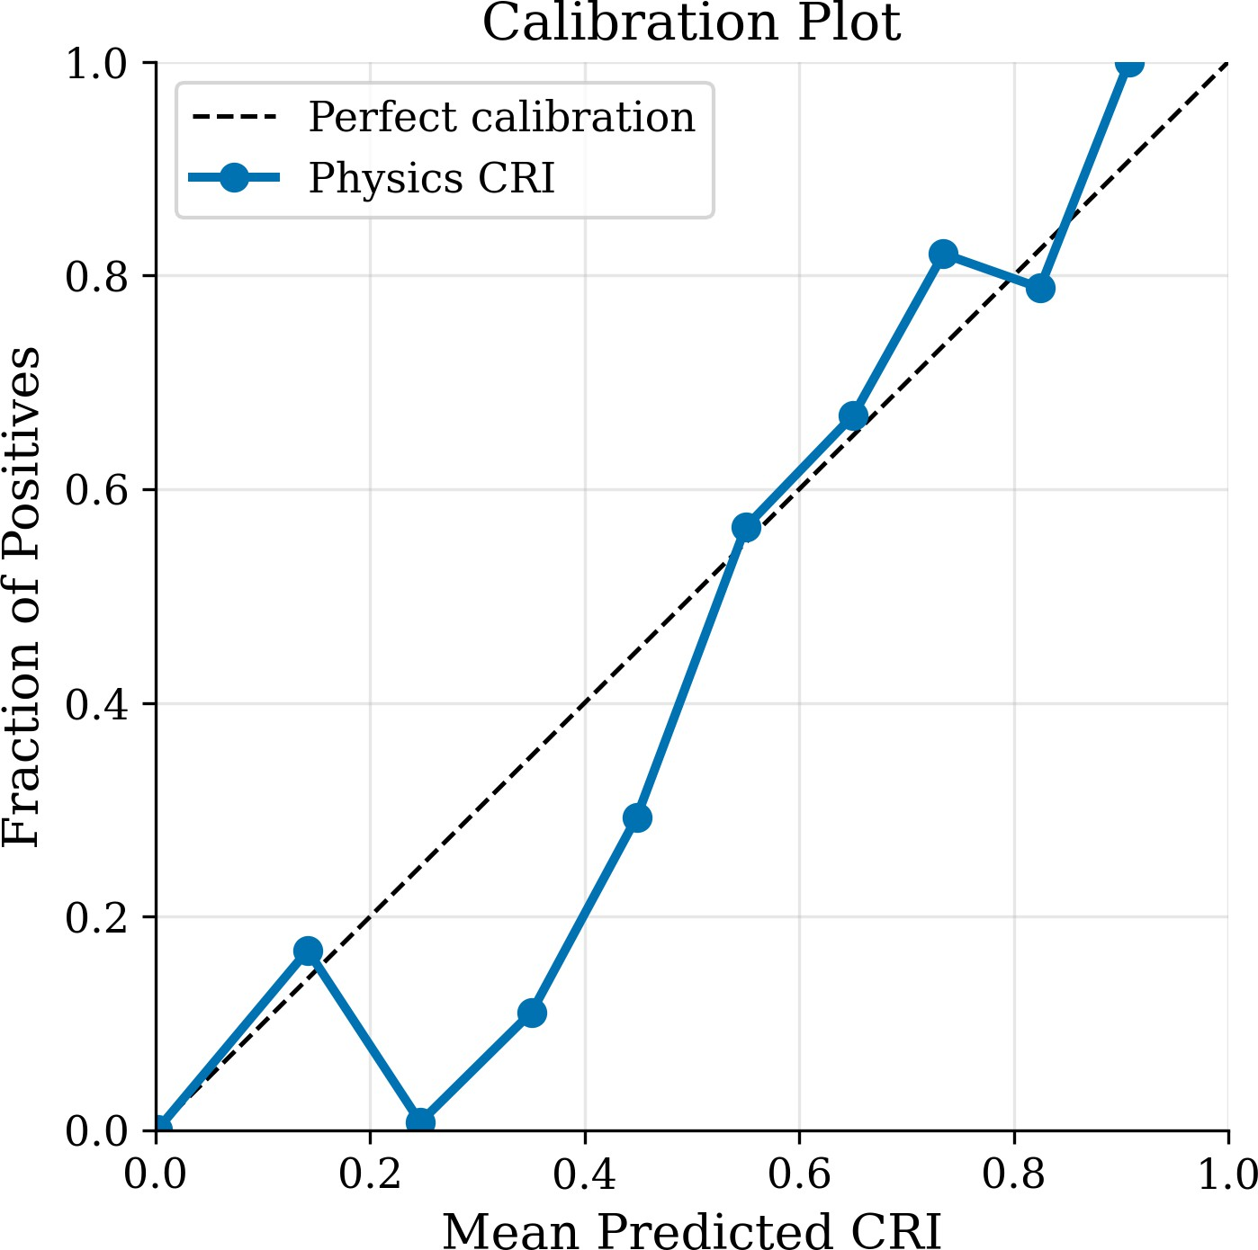
Fig. 18 Calibration plot: predicted CRI vs. observed positive frac-tion. The proxy ground truth uses kinematic near-miss events (2.37% positive rate).

column is reproduced by fast_ablation.py on the published dataset.) A5 (α = 0.20, β = 0.80) is selected over A2 (α = 0.50, β = 0.50) because of better AUC rank-ordering on the Tier 2 proxy (0.9869 vs. 0.9842 on the seed-42 single-run point estimate, the same quantity reported rounded as 0.987 in Table 4), despite nearly identical single-threshold F1.
Table 11 Ablation Study Results

Config | α | β | γ | Lat TTC | F1 (0.60) | F1 (0.80)
A1 | 1.00 | 0.00 | 0.00 | × | 0.652 | 0.029
A2 | 0.50 | 0.50 | 0.00 | × | 0.583 | 0.024
A3 | 0.35 | 0.45 | 0.20 | × | 0.328 | 0.001
A4 | 0.35 | 0.45 | 0.20 | ✓ | 0.328 | 0.001
A5 | 0.20 | 0.80 | 0.00 | ✓ | 0.583 | 0.024

Sensitivity Analysis
The purpose of Fig. 19 is to establish the operating envelope of the engine: each panel sweeps one parame-ter (GPS noise, packet-loss probability, TTC threshold, alert threshold, friction) with all others held at their published values, and reports the resulting detection quality, showing which parameters the system is and is not sensitive to. The system maintains strong per-formance under parameter variation: robust with GPS noise up to 3.0 m and packet loss up to 20%.
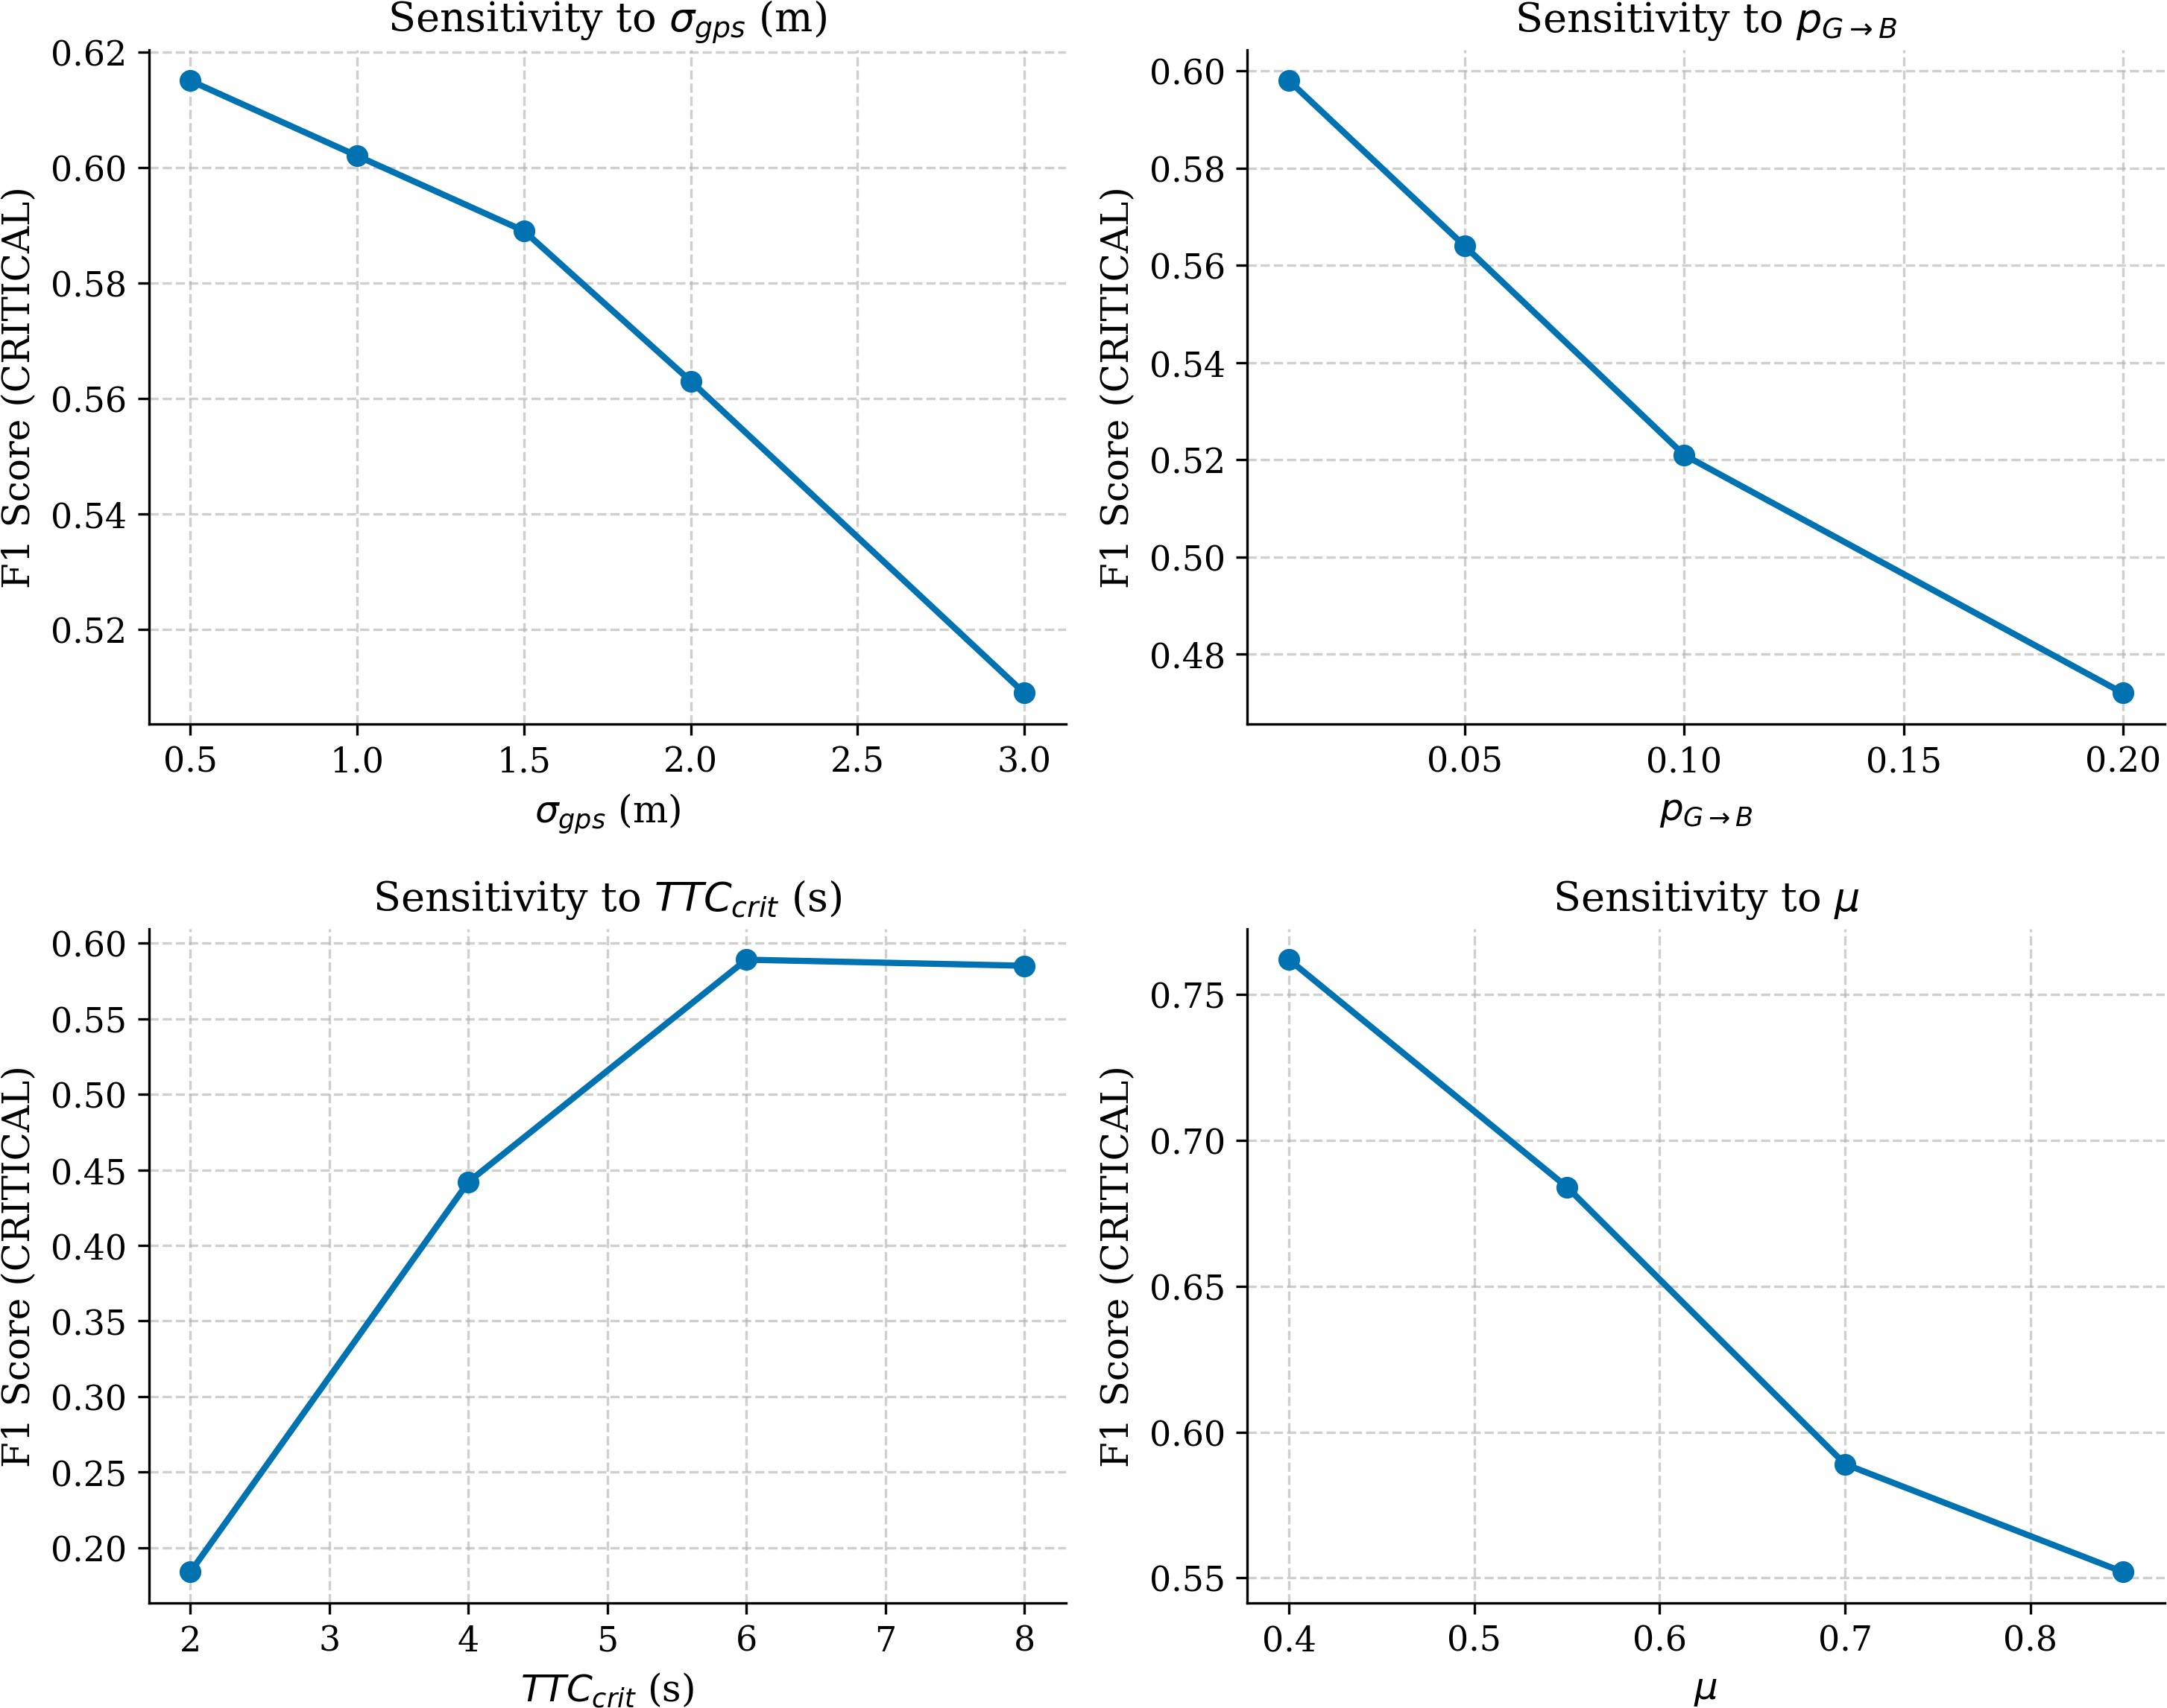
Fig. 19 Sensitivity analysis across GPS noise, packet loss, TTC threshold, alert threshold, and friction values.

Real-World Deployment Pathway
Deploying this system on real vehicles requires only a standard DSRC or C-V2X On-Board Unit (OBU) that can transmit the 5-field BSM. Because the sys-tem uses only position, speed, and acceleration values, it does not need access to the vehicle’s internal com-puter network for turn signals or steering data. This makes it compatible with existing aftermarket V2V communication kits.

For embedded hardware deployment, the CRI logic has been packaged as a ROS2 node that converts GPS coordinates into the local coordinate frame used by the physics engine. A single processing cycle with 15 simultaneous targets completes in 4.7 ms, well within the 100 ms time budget required by the SAE J2945/1 standard.
The XGBoost model is exported in ONNX for-mat for potential future embedded inference, pending improvement with additional training data. The physics model is the sole decision-maker in the current deploy-ment configuration.
Current status: All results in this paper are from simulation. Hardware testing on physical vehicles is planned as future work. The ROS2 wrapper and ONNX export have been validated in software-only testing.

Discussion
The main finding is that the transparent physics model significantly outperforms both kinematic baselines and the exploratory XGBoost model on the same 5-field BSM input. The Tier 1 model-independent ranking
(Physics 0.958, TTC 0.788, XGBoost 0.779, Static 0.766) places the physics model clearly above every alternative with non-overlapping confidence intervals, and the paired bootstrap test rejects equality at p <
0.001. The Tier 2 proxy-based ranking is consistent
with Tier 1, ruling out the concern that the proxy is flat-
tering the model through input overlap. The severity gate — requiring at least one physical danger signal to be genuinely high before any composite score escalates
— is the architectural feature that creates this separation. The ablation study (Table 11) confirms it: removing the gate by adding the unreliable intent component (γ = 0.20) reduces F1 by 44%.
The XGBoost result, and the comparison with the
three additional learners in Section 7.6, is best read as an instructive negative result. All four data-driven clas-sifiers cluster within a narrow performance band on the easy classes and fail uniformly on the CRITICAL class. This is not a property of any one algorithm: with 41 real CRITICAL training rows (augmented with 300 synthetic exemplars and SMOTE-expanded to 500), no learner has enough genuine signal to confidently distinguish the CRITICAL region from the WARN-ING region. The cost-sensitive operating-point analysis (Table 8) sharpens the point: even granting each learner a tuned decision threshold, meaningful sensitivity on the 13 held-out CRITICAL events is only purchasable at hundreds of false alarms per true event. The physics
model, by contrast, encodes the rare-event boundary through stopping-distance and TTC geometry, which is information no amount of training data could replace cheaply.
The system maintains consistent performance across the three scenario tags (∆AUC ≤ 0.002) and across six independent random traffic seeds (σ = 0.0041, Table 10).

Limitations.
The evaluation is from microscopic simulation only. Real-world V2V deployment will face channel patholo-gies (multipath, ramped-up GPS error in urban canyons, BSM signing overhead) that the Gilbert–Elliott model does not capture. The validation network is a sin-gle corridor in Navi Mumbai; generalisation to other geometries is untested. The Tier 2 proxy shares inputs with the CRI score, although the Tier 1 collision-only result (Section 7.2) provides an input-independent check. That check itself rests on only 27 collision events, and those events are generated by the same simulator car-following and lane-change dynamics that shape the gap and TTC quantities the CRI consumes, so its independence is label-computational rather than absolute (Section 7.1); no real-world or third-party-dataset validation is included in this paper, and we regard the headline AUC values as simulation-internal evidence pending the on-road validation outlined below. The simulated fleet contains only motorised four-wheeled vehicles — pedestrians, cyclists, and two-wheelers are deliberately out of scope here because they would require V2X-Pedestrian (PSM) message handling and bicycle dynamics that the current CRI engine does not model. With turn-signal information unavailable in the 5-field BSM, the intent component is disabled in the final configuration, so a lane-change manoeuvre by the target (as opposed to the ego) is detected only through its lateral-geometric conse-quences. CRITICAL-class events remain extremely rare (54 in 146,051 rows), bounding the statistical power of any classifier evaluation at that severity level.

Conclusion
This paper presented a V2V blind-spot detection sys-tem that operates on only five fields of the standard SAE J2735 Basic Safety Message (position, speed, acceleration, deceleration), and that converts those sig-nals into a Collision Risk Index via a severity-gated formula. The severity gate is the principal contribution: by requiring that at least one of the deceleration-risk

or TTC-risk components reach a genuinely danger-ous level before any composite score escalates, the design suppresses the false-alarm accumulation that hurts simpler weighted-sum formulations.
The physics model was evaluated over 146,051 sim-ulated observations on a real-world road network (Atal Bridge corridor, Navi Mumbai, India). Against a label-independent collision ground truth (n = 27) it achieved
AUC = 0.958 with 95% bootstrap CI [0.944, 0.970],
statistically significantly better than the TTC kinematic
baseline, the static box baseline, and the exploratory XGBoost classifier (paired bootstrap, p < 0.001); three further learners (LightGBM, Random Forest, Logistic Regression), evaluated on the four-class alert task, hit the same rare-event ceiling as XGBoost. A held-out
calibration check confirmed that the published weights α = 0.20, β = 0.80 are not artefacts of test-set fit-ting — the train-only optimal weights generalise to almost identical held-out test performance. SHAP anal-ysis of the exploratory XGBoost classifier confirmed
that the features the data-driven model relies on (gap distance, number of targets) are the same quantities the physics CRI engine treats as primary, supporting interpretability of both routes.

Future work.
Four directions follow naturally from the limitations above:
- On-road validation. Deploy the same engine on an off-the-shelf DSRC or C-V2X on-board unit and val-idate against an instrumented vehicle. Real channel noise, BSM signing overhead, and GPS multipath in urban canyons cannot be evaluated in simulation.
- Vulnerable road users (VRUs). Extend the sys-tem to consume Personal Safety Messages (PSMs) for pedestrians, cyclists, and two-wheelers. This requires a modified R_{decel} that does not assume vehicle-class mass and braking, plus a redesigned blind-spot zone for non-motorised actors.
- More scenarios, including static-traffic conditions. The current evaluation focuses on dynamic con-flict cases (lane-change with closing vehicles, signal violations, narrow roads). Static or quasi-static sce-narios — congestion, slow-and-stop traffic, queue tails approaching an intersection — exercise differ-ent parts of the engine (low ego speed, sustained near-zero relative velocity) and would broaden the validation envelope.
- Multi-network generalisation. Evaluate on addi-tional road geometries (motorways without merge
lanes, signalised arterials, roundabouts) and against published surrogate-safety benchmarks to demon-strate transferability beyond the single corridor used here.
A possible fifth direction, suggested by the reviewer process, is the use of a driving-simulator with human-subject participation to capture decision-making in lane-change conflicts that SUMO’s car-following mod-els approximate but do not reproduce.
Acknowledgements. The authors thank the Eclipse SUMO development team (DLR) for the open-source traffic simulation platform, and OpenStreetMap con-tributors for the Atal Bridge road network data.
Funding Declaration. The authors declare that no funding was received for this research work.
Ethics, Consent to Participate, and Consent to Publish. Not applicable.
Competing interests. The authors declare no com-peting interests.
Data Availability Statement. This study uses no proprietary, restricted, or third-party benchmark dataset. The road-network geometry of the Atal Setu corridor, Navi Mumbai, India, was obtained from OpenStreetMap (© OpenStreetMap contribu-tors, ODbL v1.0; https://www.openstreetmap.org/) on 26 September 2025 within the bounding box (lat 18.99201–19.00297° N, lon 72.84648–72.86214° E)
and converted to a SUMO microscopic-traffic net-work using netconvert v1.24.0. All vehicle trajec-tories, Basic Safety Messages (BSMs), kinematic near-miss labels, ablation tables, and trained model artifacts were generated by the Eclipse SUMO 1.19+ microscopic simulator under the deterministic random seed 42 using the open-source scripts in this repos-itory: https://github.com/omkarrr88/V2V. The com-plete synthetic dataset (Outputs/bsd_metrics.csv,
146,051 rows × 45 columns), the trained XGBoost
model (Outputs/bsd_xgboost_model.json), the
alert log (Outputs/bsd_alerts.csv), and the abla-tion/sensitivity tables are committed to the same repos-itory. No human-subject data, no personal data, and no real-vehicle telemetry were used.

References
- SAE International, “Dedicated Short Range Com-munications (DSRC) Message Set Dictionary,” SAE Standard J2735_202309, Sep. 2023.

- SAE International, “On-Board System Require-ments for V2V Safety Communications,” SAE Standard J2945/1_201603, Mar. 2016.
- IEEE, “IEEE Standard for Information Technol-ogy — Wireless Access in Vehicular Environ-ments,” IEEE Std 802.11p-2010, Jul. 2010.
- 3GPP, “Study on LTE-based V2X Services,” 3GPP TR 36.885 V14.0.0, Jun. 2016.
- Euro NCAP, “Lane Change Assist System (LCAS) Test Protocol,” Version 1.0, 2019.
- AASHTO, A Policy on Geometric Design of Highways and Streets, 7th ed. Washington, DC, 2018.
- E. N. Gilbert, “Capacity of a burst-noise channel,” Bell Syst. Tech. J., vol. 39, no. 5, pp. 1253–1265, Sep. 1960.
- T. Chen and C. Guestrin, “XGBoost: A scalable tree boosting system,” in Proc. ACM SIGKDD, San Francisco, CA, Aug. 2016, pp. 785–794.
- P. A. Lopez et al., “Microscopic traffic simulation using SUMO,” in Proc. IEEE ITSC, Maui, HI, Nov. 2018, pp. 2575–2582.
- World Health Organization, “Global Status Report on Road Safety 2023,” WHO, Geneva, Dec. 2023.
- MoRTH, “Road Accidents in India 2022,” Gov-ernment of India, New Delhi, Oct. 2023.
- A. Mousa et al., “Vehicle-to-vehicle communica-tion for blind spot detection,” IEEE Trans. Intell. Transp. Syst., vol. 22, no. 5, pp. 3120–3131, May
2021.
- A. Festag, “Cooperative intelligent transport sys-tems standards in Europe,” IEEE Commun. Mag., vol. 52, no. 12, pp. 166–172, Dec. 2014.
- S. Biswas, R. Tatchikou, and F. Dion, “Vehicle-to-vehicle wireless communication protocols for enhancing highway traffic safety,” IEEE Commun. Mag., vol. 44, no. 1, pp. 74–82, Jan. 2006.
- N. Chawla et al., “SMOTE: Synthetic minority over-sampling technique,” J. Artif. Intell. Res.,
vol. 16, pp. 321–357, 2002.
- B. Kim et al., “An IMM/EKF approach for enhanced multitarget state estimation for inte-grated threat assessment,” IEEE Trans. Veh. Technol., vol. 64, no. 3, pp. 876–889, Mar. 2015.
- Z. A. Rawashdeh and S. M. I. Mahmud, “A novel V2V-based blind spot detection system,” in Proc. IEEE VTC-Fall, Calgary, AB, Sep. 2008, pp. 1–5.
- S. M. Lundberg and S.-I. Lee, “A unified approach to interpreting model predictions,” in Proc. NeurIPS, Long Beach, CA, Dec. 2017,
pp. 4765–4774.
- J. C. Hayward, “Near-miss determination through use of a scale of danger,” Highway Research Record, no. 384, pp. 24–34, 1972.
- M. M. Minderhoud and P. H. L. Bovy, “Extended time-to-collision measures for road traffic safety assessment,” Accident Anal. Prev., vol. 33, no. 1,
pp. 89–97, Jan. 2001.
- NHTSA, “Forward Collision Warning System Confirmation Test,” U.S. Dept. of Transportation, National Highway Traffic Safety Administration, Office of Vehicle Safety, Washington, DC, Feb. 2013.
- E. O. Elliott, “Estimates of error rates for codes on burst-noise channels,” Bell Syst. Tech. J., vol. 42, no. 5, pp. 1977–1997, Sep. 1963.
- T. Fawcett, “An introduction to ROC analysis,” Pattern Recognit. Lett., vol. 27, no. 8, pp. 861–
874, Jun. 2006.
- J. Davis and M. Goadrich, “The relationship between precision-recall and ROC curves,” in Proc. 23rd Int. Conf. Machine Learning (ICML), Pittsburgh, PA, Jun. 2006, pp. 233–240.
- B. Efron and R. J. Tibshirani, An Introduction to the Bootstrap. New York, NY: Chapman & Hall, 1993.
- R. Xu, H. Xiang, X. Xia, X. Han, J. Li, and
J. Ma, “OPV2V: An open benchmark dataset and fusion pipeline for perception with vehicle-to-vehicle communication,” in Proc. IEEE ICRA,

Philadelphia, PA, May 2022, pp. 2583–2589.
- R. Xu, H. Xiang, Z. Tu, X. Xia, M.-H. Yang, and
J. Ma, “V2X-ViT: Vehicle-to-everything coopera-tive perception with vision transformer,” in Proc. ECCV, Tel Aviv, Israel, Oct. 2022, pp. 107–124.
- R. Xu et al., “V2V4Real: A real-world large-scale dataset for vehicle-to-vehicle cooperative percep-tion,” in Proc. IEEE CVPR, Vancouver, BC, Jun. 2023, pp. 13712–13722.
- Y. Li, D. Ma, Z. An, Z. Wang, Y. Zhong, S. Chen, and C. Feng, “V2X-Sim: Multi-agent collab-orative perception dataset and benchmark for autonomous driving,” IEEE Robot. Autom. Lett., vol. 7, no. 4, pp. 10914–10921, Oct. 2023.
- A. Caillot, S. Ouerghi, P. Vasseur, R. Boutteau, and Y. Dupuis, “Survey on cooperative percep-tion in an automotive context,” IEEE Trans. Intell. Transp. Syst., vol. 23, no. 9, pp. 14204–14223,
Sep. 2022.
- S. Liu, C. Gao, Y. Chen, X. Peng, X. Kong,
K. Wang, R. Xu, W. Jiang, H. Xiang, J. Ma, and J. Ma, “Towards vehicle-to-everything autonomous driving: A survey on collaborative perception,” IEEE Trans. Intell. Transp. Syst., vol. 25, no. 5, pp. 3614–3633, May 2024.
- K. Garlichs, M. Wegner, and L. C. Wolf, “Design-ing C-V2X for connected and automated driving,” IEEE Veh. Technol. Mag., vol. 18, no. 3, pp. 46–55, Sep. 2023.

